CS 608 – Algorithms and Computing Theory

Class 1 – August 27th, 2020

The world of computing today – Fast algorithms are crucial because of big data!

Discreet Math Review:

Exponentiation:

X^a x^b = x^ a+b

X^a / x^b = x^ a-b

(x^a)^b = X^ab

2^n + x^n = 2x^n

2^n + 2^n = 2,2^n = 2^n+1

Logarithm: (GOOGLE DEFINITION)

logxB = A -> x^A = B

log2B = A -> 2^A = B

log2 used so frequently it is written simply as lg

logxB = A -> X^A = B

**The CS interpretation of log2 (lg):**

**lg n means the number of times that I can divide n by 2 before getting 1**

lg n = B 🡪 2^B = n 🡪 n / 2^b = 1

1. lg(A*B) = lg A + lg B

2. lg(A/B) = lg A – lg B

3. lg X^A = A * lg X (SAME PROPERTY AS 1)

Summations <https://i.gyazo.com/71afa1bfaae10f68e76d2c5329b8b891.png>

Proof Techniques:

1) Induction

2) Contradiction

3) Counterexample

1) Induction – Applies to cases where you must prove infinitely many cases. Cannot prove every single case, so must prove that if one is true, the next one will also be true.

* If ith domino falls, i+1th domino will fall as well. Because I can be any domino in the iteration, and is not fixed, so it can prove for any domino.
* APPLY DEFINITION AND INDUCTIVE HYPOTHESIS

Example: Fibonacci series (infinite series of numbers where each number is the sum of the previous 2 numbers. (1, 1, 2, 3, 5, 8, 13, 21, 34, 55, 89, …..) <https://i.gyazo.com/44115046fbcdb3fb5fa65a4b99471590.png>

Base Case: <https://i.gyazo.com/5fc6366f21cc2354eda3fbd2df02374e.png>

Inductive Step:

* Inductive hypothesis – assume that the case is true for all cases

<https://i.gyazo.com/a6ff28166b8469e4f463c18fa142bb87.png>

<https://i.gyazo.com/c1679ec15cbdc5195968bb8071f4e8a6.png>

<https://i.gyazo.com/cbf95e0a0c8b3f61405f873e478e911d.png>

2) Contradiction – Assume that what we want to prove is false, then we contradict either our own assumption or something else

Example:

Theorem: There is an infinite number of prime numbers.

Proof:

For the sake of contradiction, assume that there is a finite number of prime numbers.

Let the prime numbers be P1, P2, P3, …, Pk.

Hence, any number X > Pk is divisible by some number that is not X or 1.

Consider the number P1 * P2 * P3 * … * Pk+1 -> is not divisible by any of the prime numbers and it is bigger than the largest prime number, Pk…

Hence, there exists one more prime number, which is a contradiction with the assumption that P1, P2, P3, … Pk where all the prime numbers.

3) Counterexample –

Example: <https://i.gyazo.com/0b22e08eb35d2ad848b5a5f89faad497.png>

Class 2 – September 3rd, 2020

Algorithm Analysis – Proving 2 things about an algorithm; correctness and resource usage (time and space)

We need 2 models of computation:

* RAM model (Random Access Machine)
  + CPU with infinite memory, data does not need to be in specific order in memory

We can count “steps” of execution, but on which input size?

<https://i.gyazo.com/7c4fa662495dad4fe653a66e201f8720.png> (Algorithm A better on small input size, B better on larger input size (n0)

Can create a new algorithm that compares input size to n0 and then chooses one of the algorithms depending (IF YOU KNOW INPUT SIZE)

We count steps as the input size grows arbitrarily large (scalable algorithms)

In what “type” of input do we count?

* Insertion Sort is a quadratic algorithm; run time grows quadratically on an arbitrary input, but if input is already sorted, it is linear algorithm

Worst Case: (largest amount of time algorithm could take)

* Gives a GUARANTEE on maximum time.

Average Case: (amount of time it takes on average)

* Usually useful information for practice.

Best Case: (smallest amount of time algorithm could take)

* Bogus information; not very useful

Counting Rules:

* Statements:
  + Assignments or Return Statements
  + Count 1 unit of time.
* If-Then-Else:
  + T1 = time of if body
  + T2 = time of else body
  + Take the max of T1 and T1, +1 (for the if condition check)
* Loop:
  + Number of iterations * time of the body of loop
* Method Call:
  + “look” inside the method
* Consecutive Statements: <https://i.gyazo.com/58c62690f2e5f5d1ff16a225a467dc9b.png>
  + Time is the sum of each statement

Summary: We count the “steps” in the RAM model as a function of the input size, for the worst-case input. So, we compare the rate of growth of the functions of time. (BigO)

Asymptotic Notation (BigO) <https://i.gyazo.com/946956902102c0184da3e9055f7bac9c.png>

Example: Place these into order of rate of growth. n^3, 2^n, n lg n, (lg n)^2, sqrt n, 1, 3^n, n

<https://i.gyazo.com/d0d5b50bf46a7ec1ce7170b78e548d8e.png>

Note: Any polynomial exponent better than n as an exponent

1, (lg n)^2, sqrt n, n, n lg n, n^3, 2^n, 3^n

7n^2 + 34n – 10

Rules of thumb to convert to asymptotic notation:

* Ignore lower-order terms (34n and 10) --- WANT TERM WITH LARGEST POWER
* Ignore multiplicative constants (7n^2)

Chapter 4: Divide and Conquer

* Divide: Divide the input problem into subproblems of smaller input sizes *(merge sort splits array in half)*
* Conquer: Solve each of the subproblems (usually recursively) *(merge sort each half)*
* Combine: Combine the solutions of the subproblems to obtain solution to the original problem *(merge both sorted halves)*

*Maximum Subarray*

Input: sequence of numbers, some positive and some negative in array A[1..n]

Output: indices i and j such that A[i..j] has the greatest sum of any non-empty contiguous subarray of A, and the sum

Example:

<https://i.gyazo.com/459973d8346d8c875a15d0f66462706d.png>

A = 3, -5, 7, 2, 1, -5, 9

Class 3 – September 10th, 2020 (Rewatch zoom call)

Recursive Trees

Substitution

1) Guess the solution of the recurrence

2) Use induction to prove that the guess is correct

Master Theorem

Trees

Examples: File system, Organization Hierarchy

Class 4 – September 17th, 2020

Binary Tree – All nodes have at most 2 children nodes

Binary Search Tree – A binary tree that also has the following characteristic:

* For any node v, the items stored in the left subtree of v are smaller than v and the items stored in the right subtree of v are larger than v

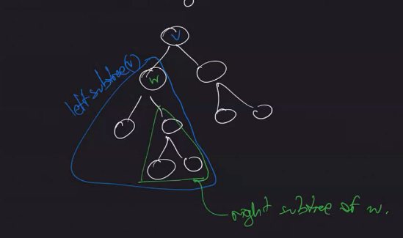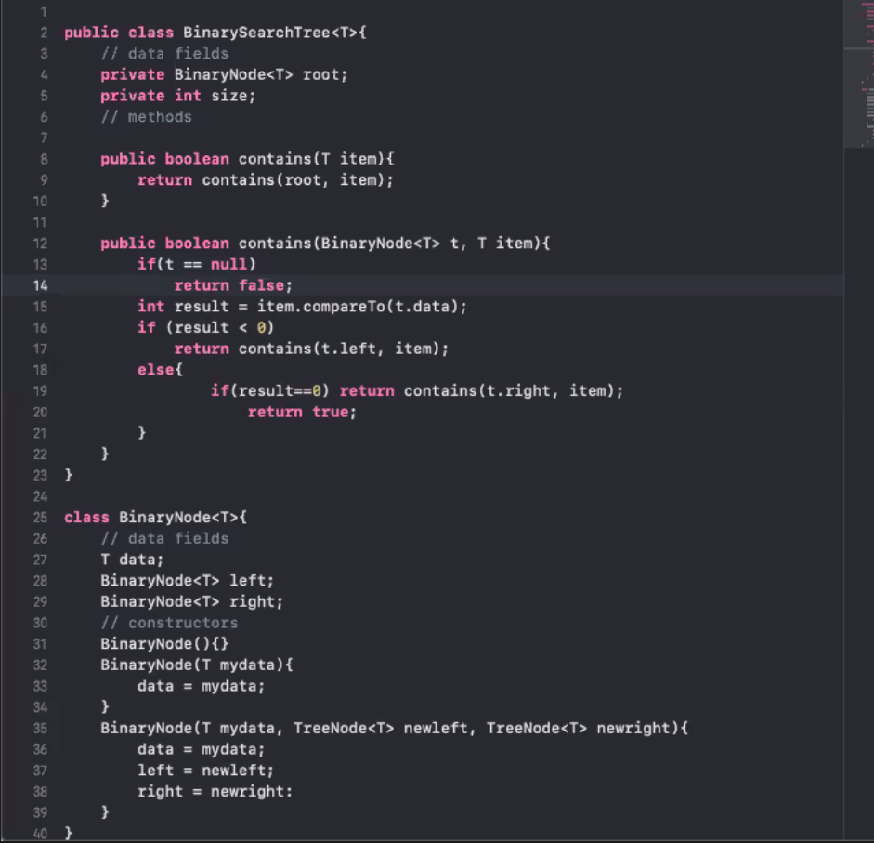

Complete Binary Tree – Binary tree that has all the nodes in all levels except possibly the last level, which has nodes on left only

Balanced Binary Tree – For each node the height of the left subtree and the height of the right subtree differ by at most one

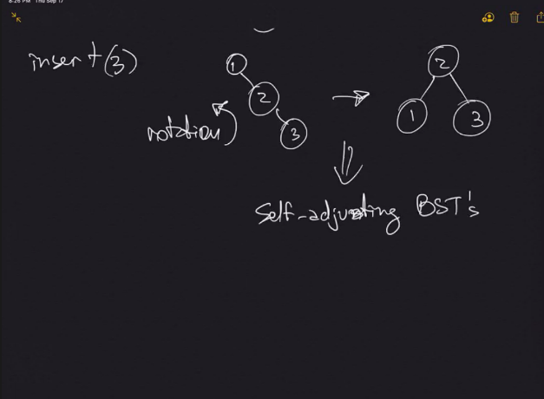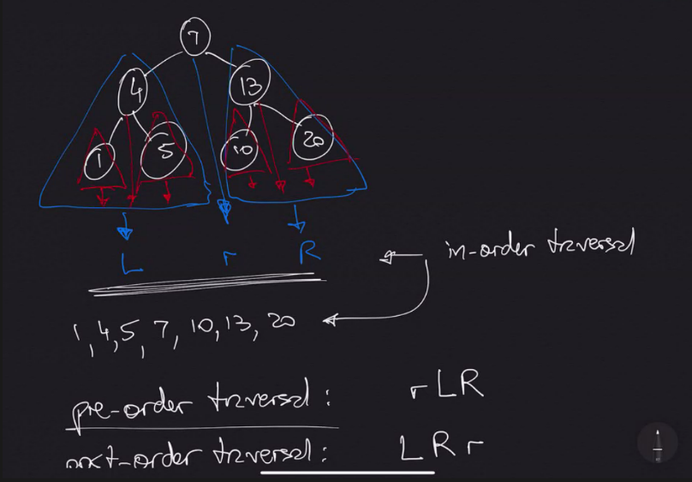

Class 5 – September 24th, 2020

Binary Tree Exercises

P9.1 – Proving that two trees are isomorphic (same shape)

* Checking recursively if each subtree is empty or not and matching to other tree

Mathematical Function:

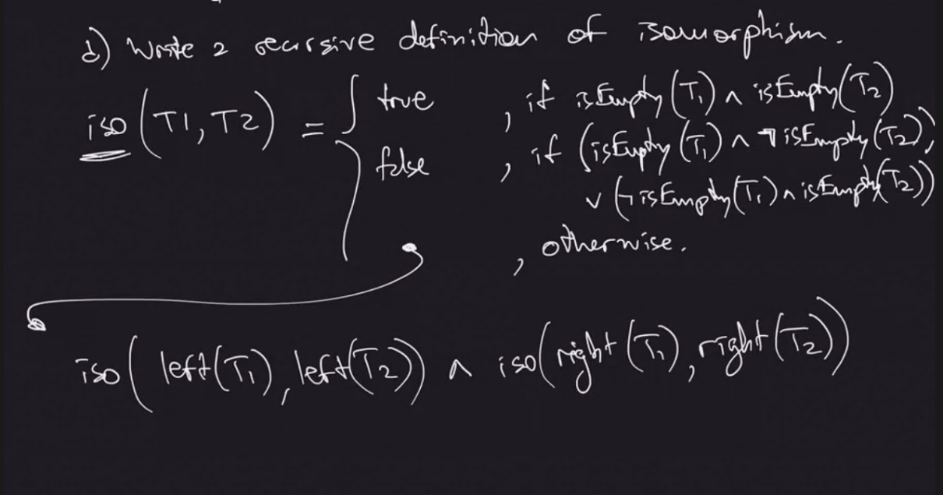

Java Code (recursion in final return):

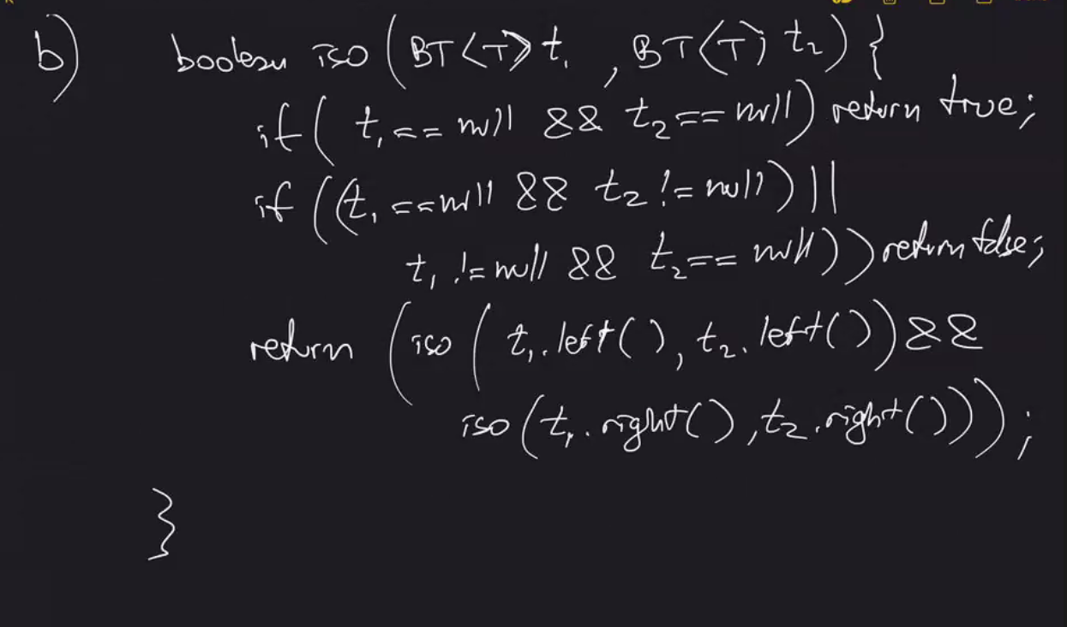

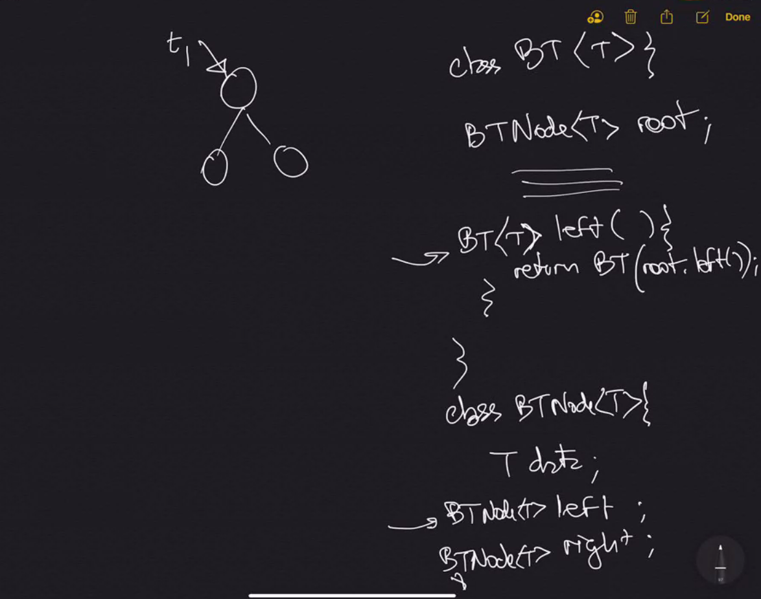

P9.3

The height of an empty binary tree is -1. The height of a single-node binary tree is 1. For a binary tree with two or more nodes, the height is the number of branches from the root to the farthest leaf.

Correct, but uses a lot of recursion and we want to avoid this:

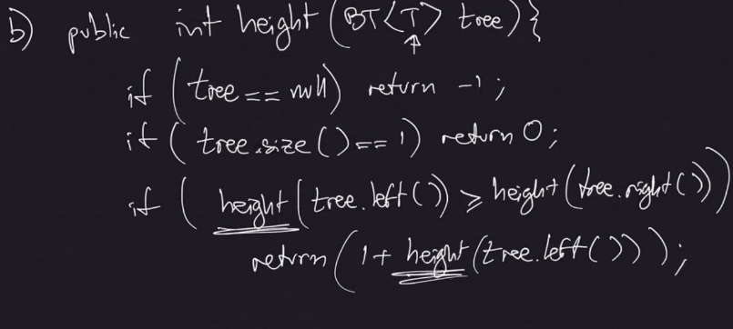

Thus we use this instead: (professor forgot an else at the end)

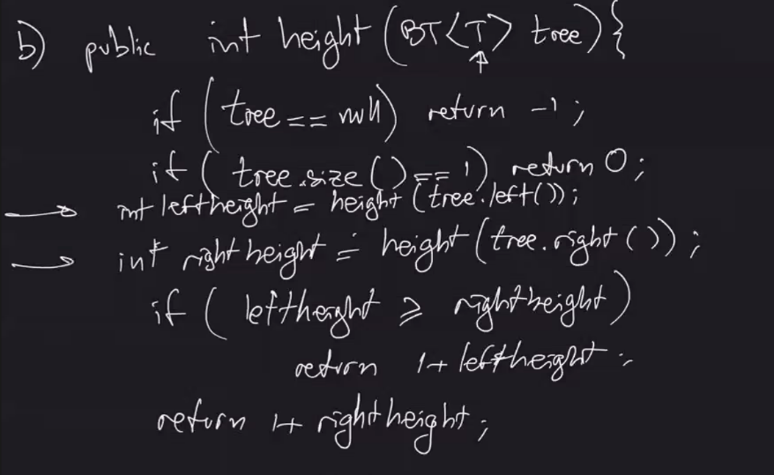

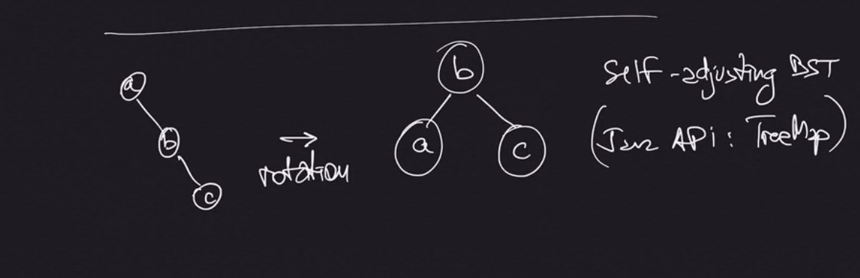

Hashing

Easy Implementation: Array

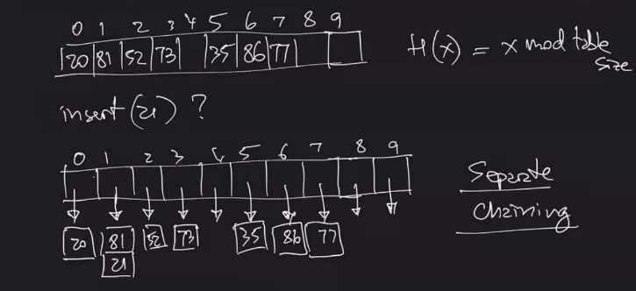

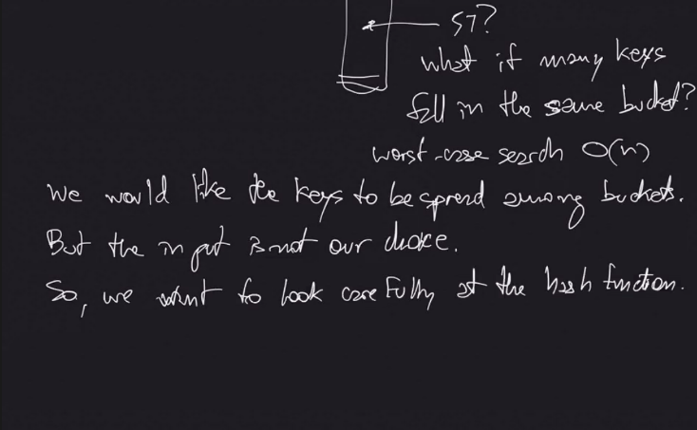

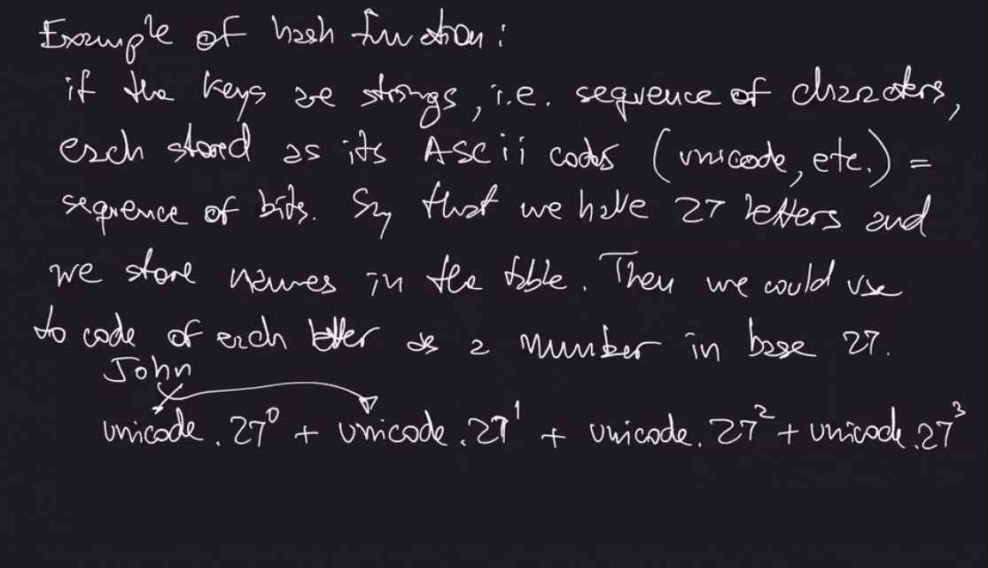

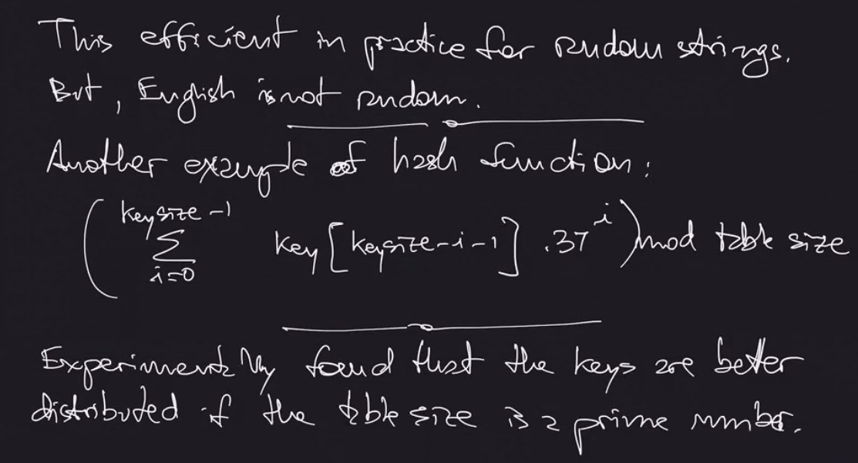

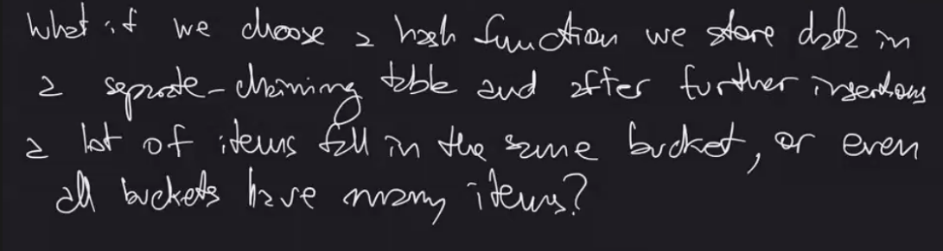



Note: Rehashing is time consuming, but amortizing over many insertions is not.

Class 6 – October 1st 2020

Hash Tables:

* Hash Function: Given a key, we obtain a location of where to store input in table
* Data Placeholder: location/structure where data is held

Universe of keys: Domain of where data can be stored

* Hash function used to reduce size of universe of locations

Collision – when two pieces of data go to same placeholder by the hash function

Separate chaining – helps resolve collision when multiple data points are in same location in universe of locations

Linear Probing – see picture below (go to next available space in order to resolve collision)

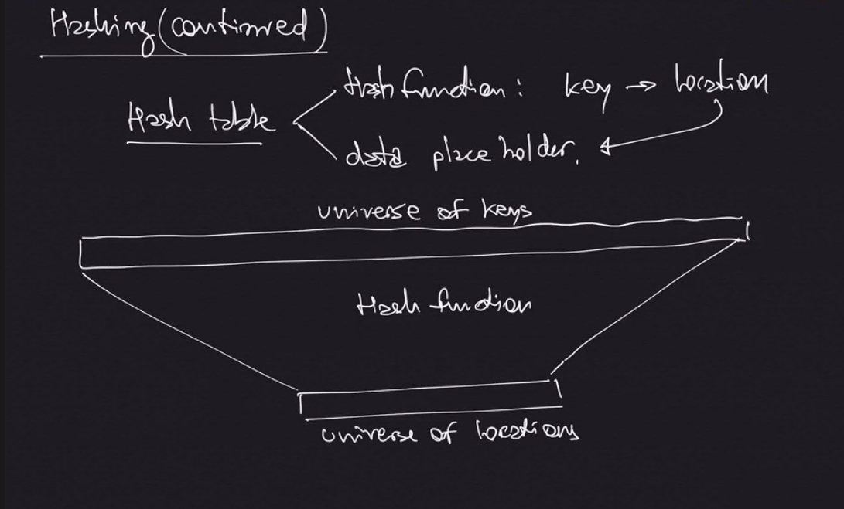

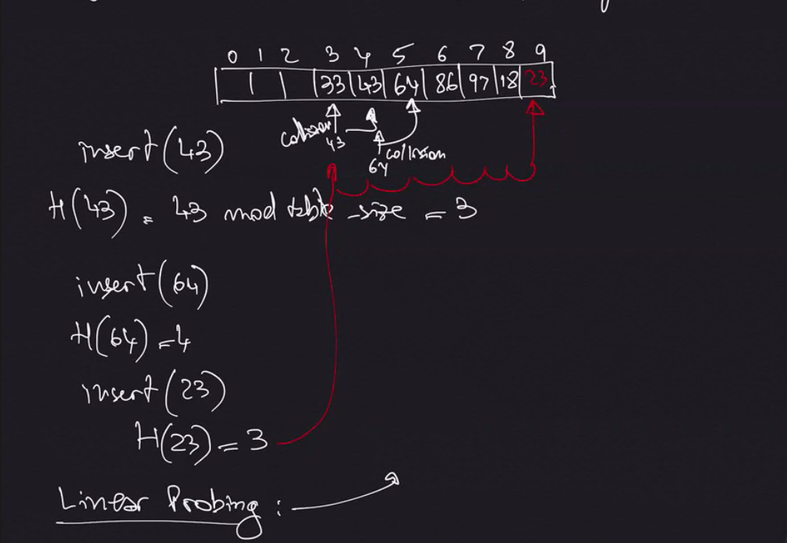

Worst-case running time for searching: O(n) HOWEVER if table allows for REMOVE operation, we could have spaces available before the item.

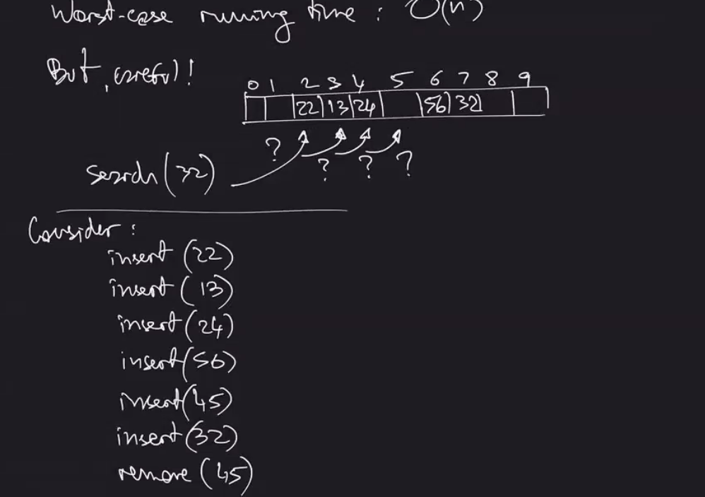



Shortcomings: The more pieces of data you input, the higher chance that there will be collision and they will be farther from the spot they are supposed to be

Quadratic Probing:

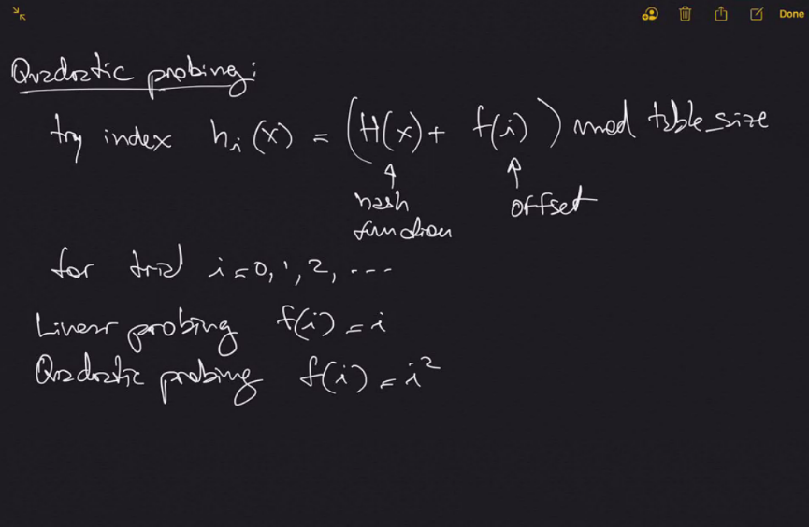

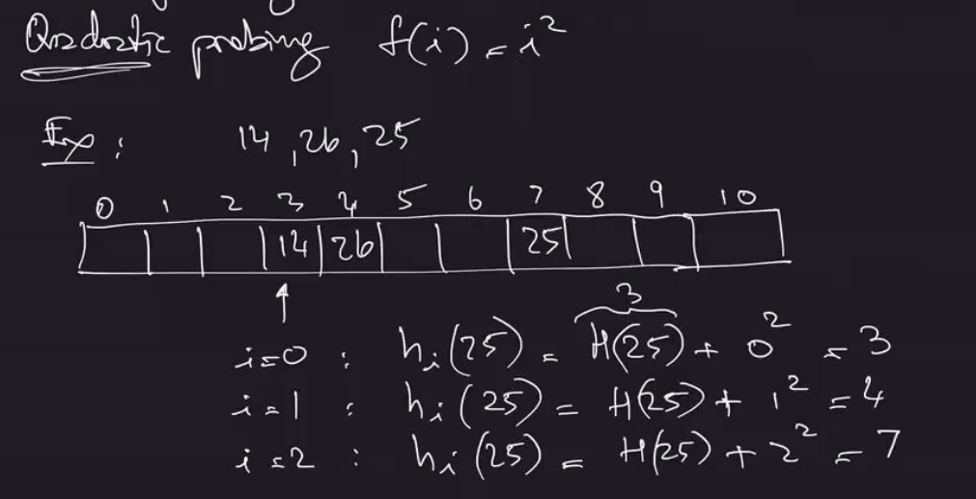

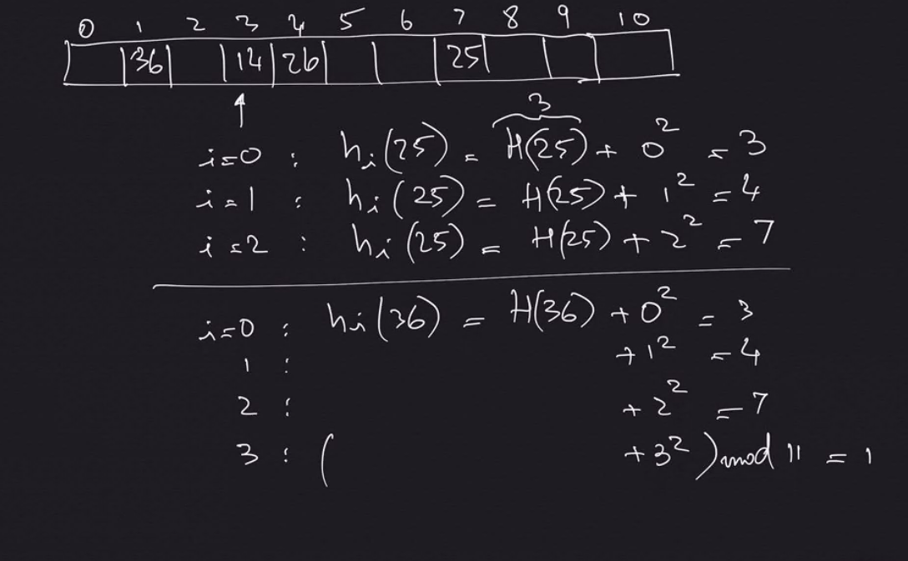

It has been observed through trial that quadratic performs better than linear, but cubic does not improve significantly over quadratic. (usually just use quadratic)

The above techniques give O(1) search cost (if the item is in the table) expected time

Perfect Hashing

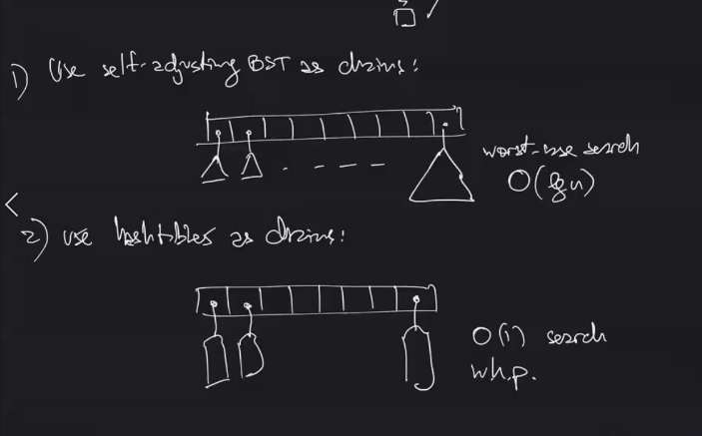

For each insertion, the chains are redefined with new has functions, until they are collision free.

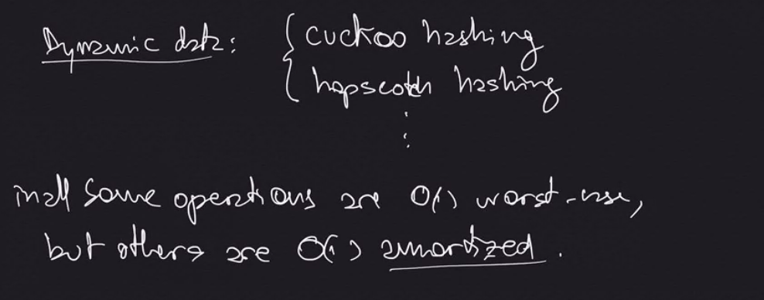

Universal Hash Functions – A family of functions from which we choose at random

Linked Lists Navigation:

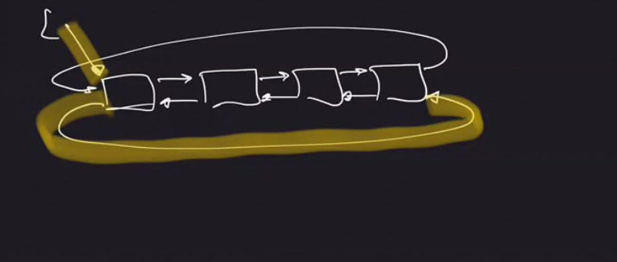

Hash Example 12.3:

A – O(1)

B – O(n2)

C – O(nlgn)

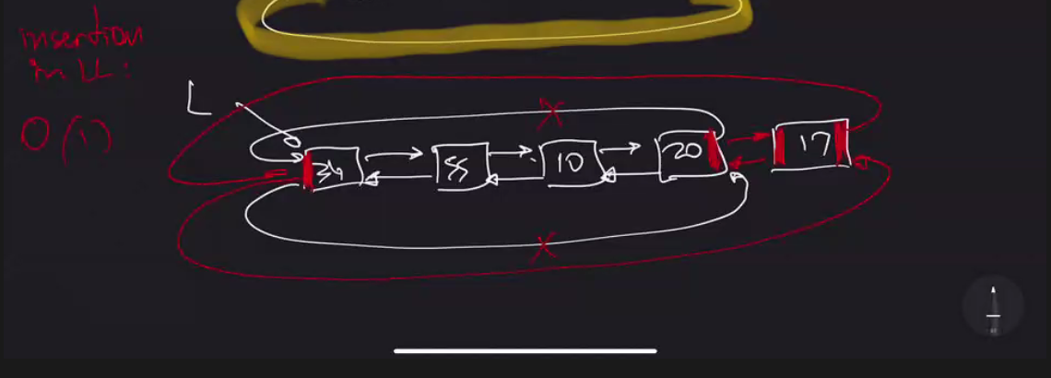

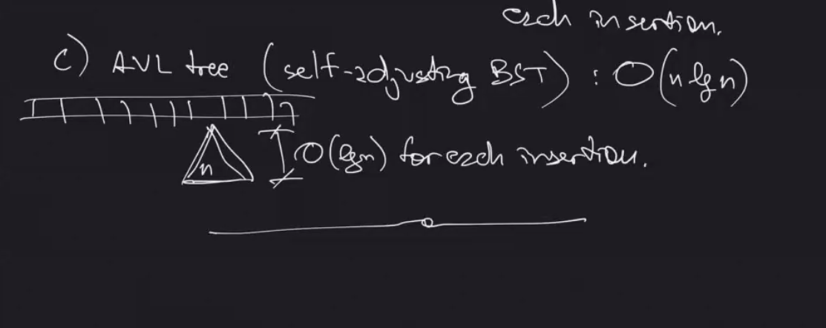

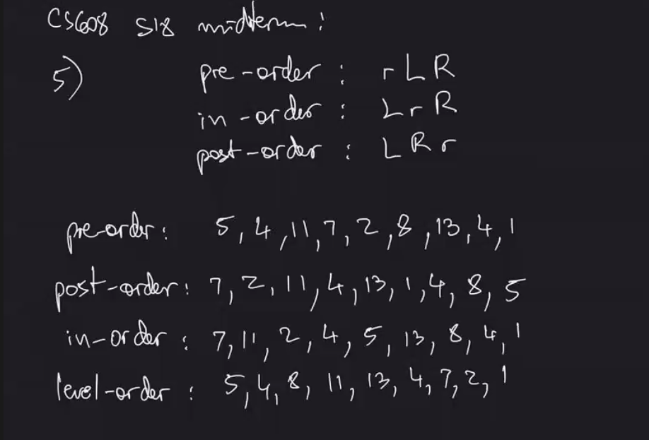

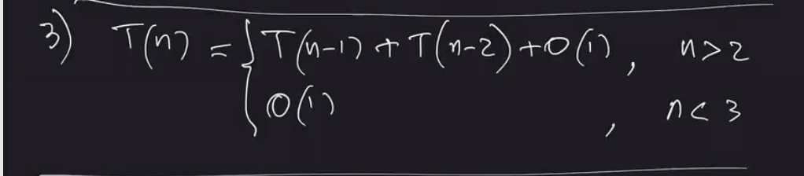

Question 2c: cannot use master theorem because n-1 not division

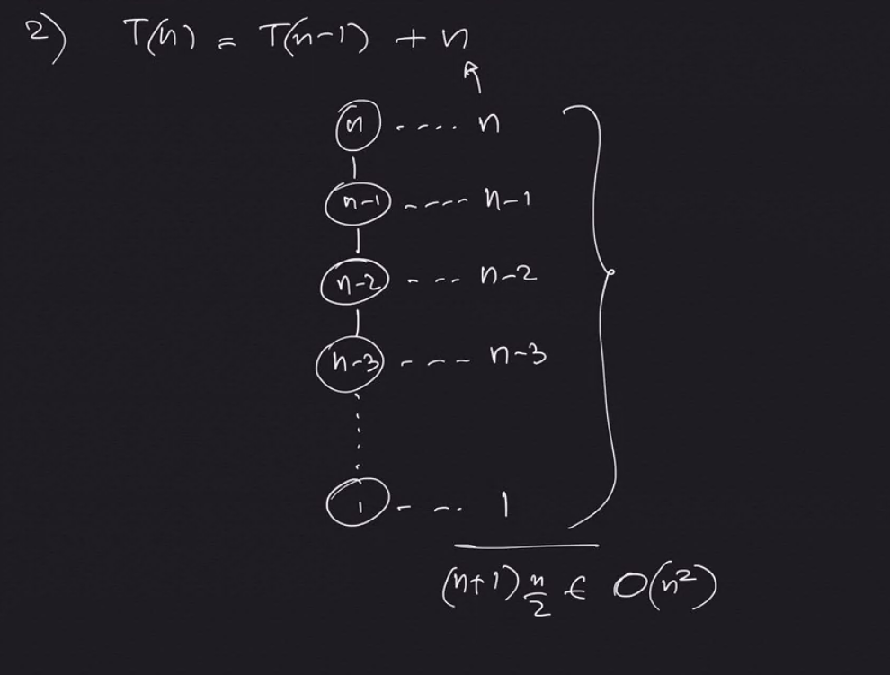

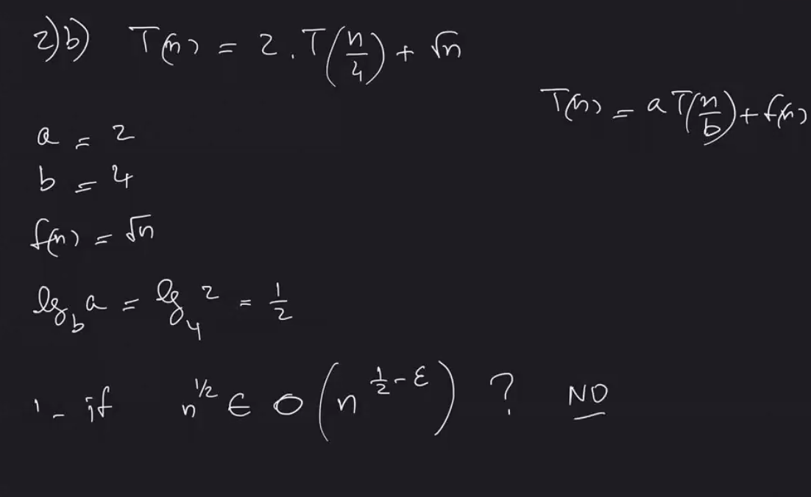

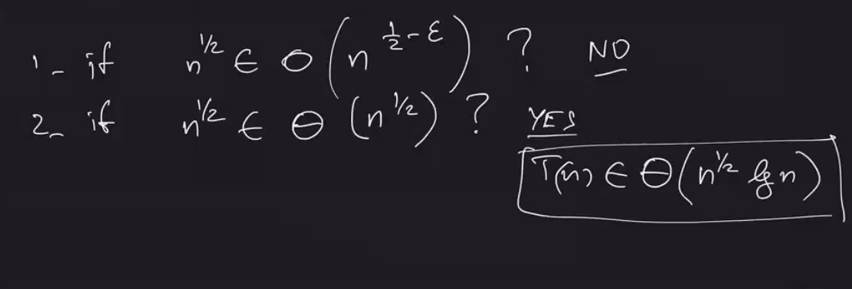

Midterm Review Topics:

Linked List

Binary Search

Recurrences

Big O, Big Theta

Trees

Pre order: root, left subtree, right subtree

In order: left, root, right

Post order: left, right, root

Level order:

Class 7 – October 15th

Sorting (chapter 6-8)

Input: a sequence of items (does not need to be numbers, must be comparable)

Output: a permutation of the input sequence with the items in increasing (or decreasing) order

**Selection Sort:**

1) Look for the minimum – O(n)

2) bring it to the front, shift all numbers to the left of min to the right and store min – O(n)

3) recurse/repeat on rest of array O(n-1)

T(n) = T(n-1) + O(n)

N + (n-1) + (n-2) ….. + 1 🡪 ALWAYS O(n^2)

Can we avoid the shifts? Yes…

**Insertion Sort:**

Simple sorting algorithm that works similar to the way you sort playing cards in your hand. Array is virtually split into a sorted and unsorted part. Values from unsorted part are picked and placed at correct spot in sorted part. (NOTE, BEST CASE IS O(n) IF ITEMS ALREADY IN ORDER.. O(n^2) is worst case)

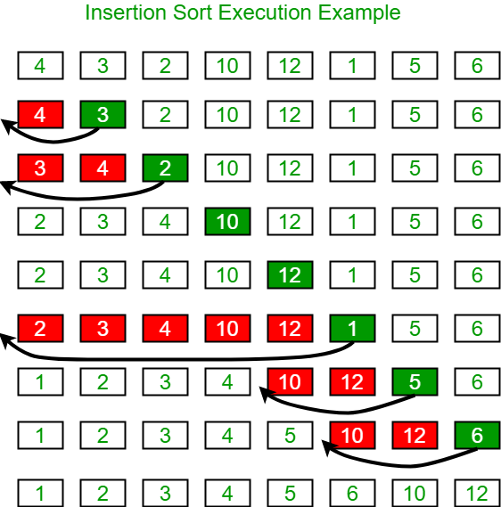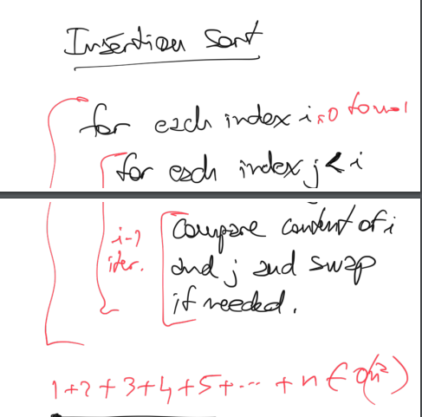

**Bubble Sort:** Simplest sorting algorithm that works by repeatedly swapping the adjacent elements if they are in order. -> ALWAYS O(n^2), UNLESS THERE ARE NO SWAPS, IT CAN STOP EARLY

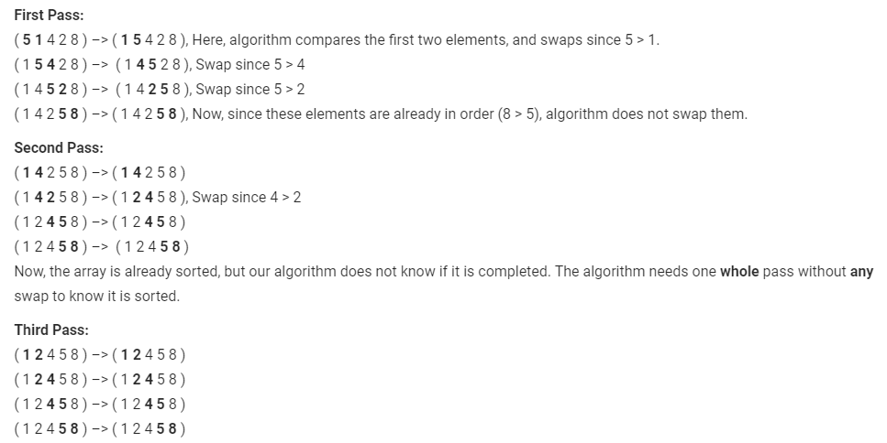

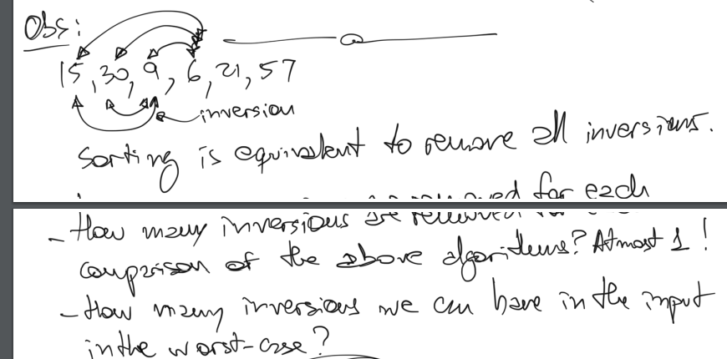

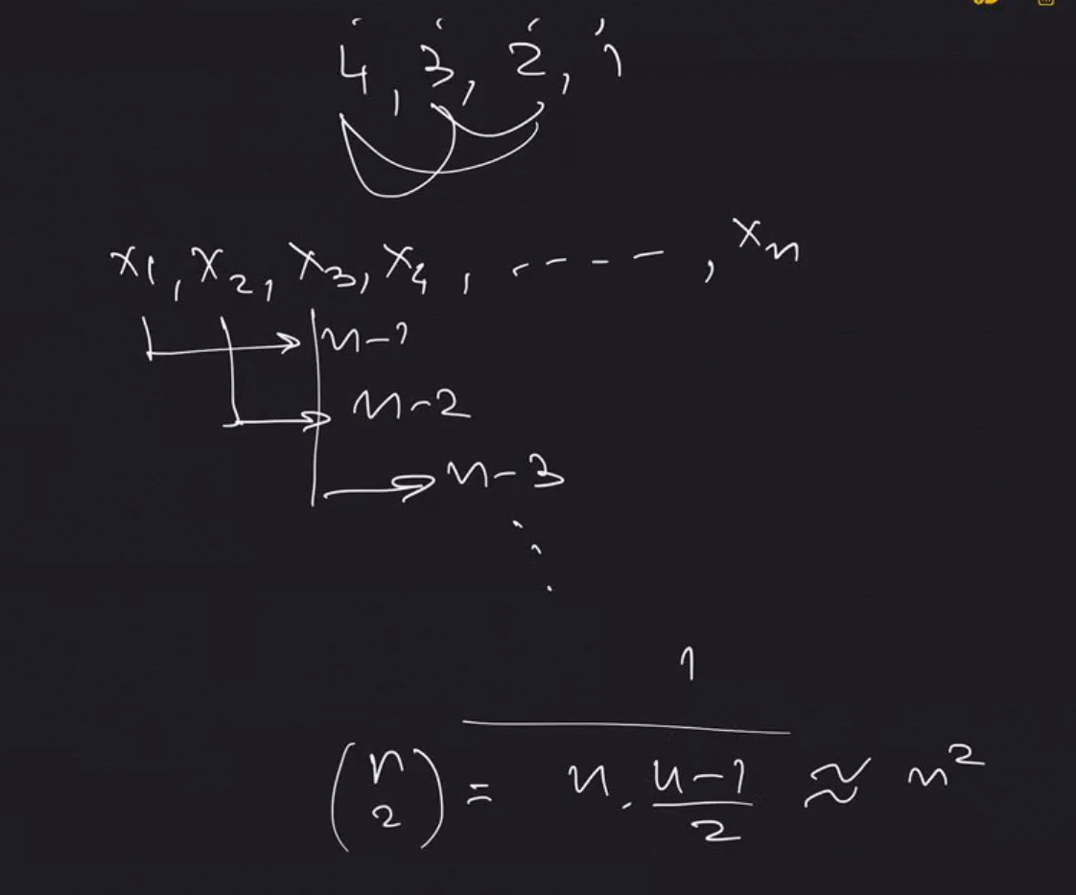

**CONCLUSION: Any algorithm that removes at most one inversion for each comparison needs at least O(n^2) comparisons in the worst case**.

**Tree Sort:**

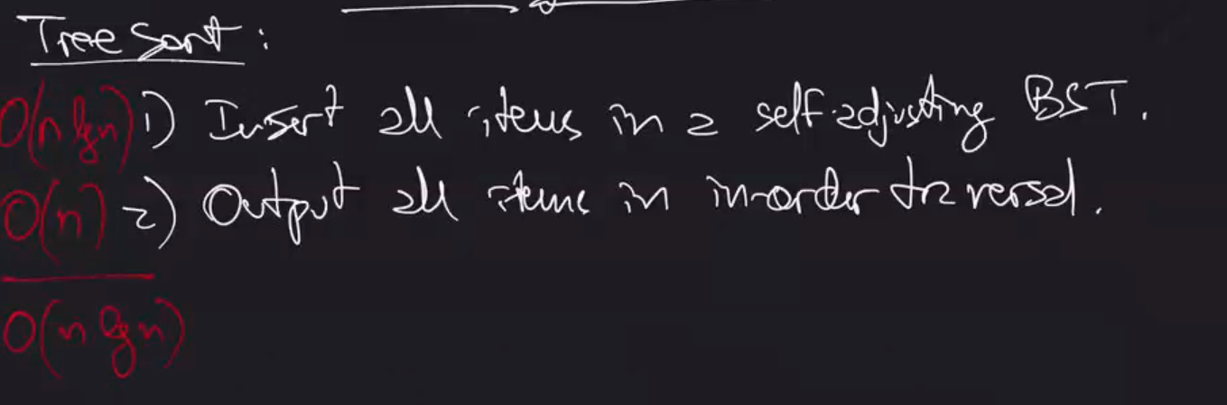

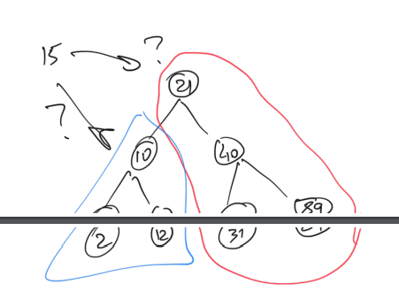

**Quick Sort:** Divide and Conquer algorithm that picks an element as the pivot and partitions the given array around the picked pivot.

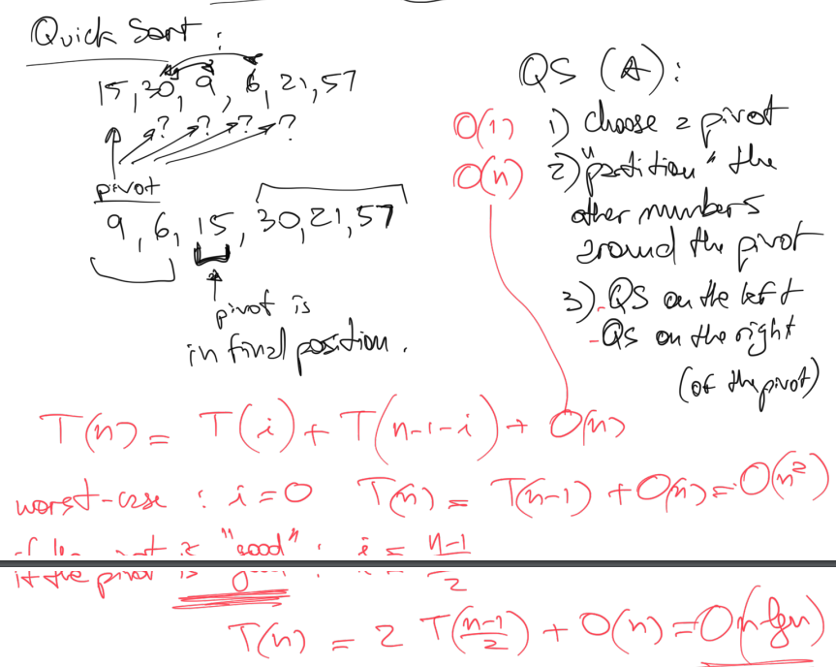

T(i) = i items on left

T(n-1-i) = total items minus pivot minus items on left, aka items on right

Worst case is when pivot would be first item, i = 0… then O(n^2)

But if pivot is good, i = (n-1)/2 --> O(n lg n)

Quick sort time depends heavily on choice of pivot

**Merge Sort:** Divide and conquer algorithm that divides input array into two halves, calls itself for the two halves and then merges the two sorted halves.

Merge by 2 finger method: compare minimums of both halves and then remove it

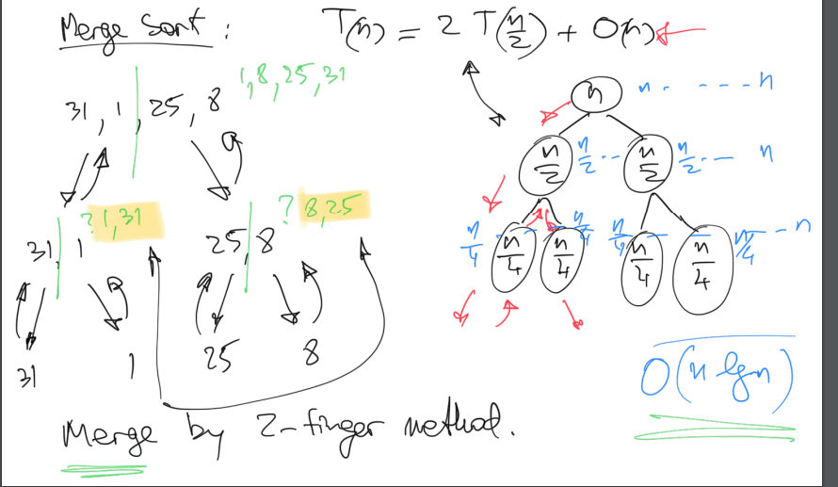

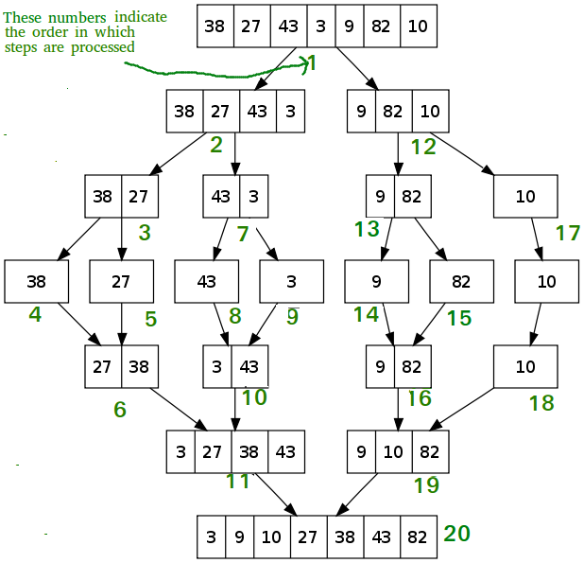



^ Asymptotic Notation for any algorithm that grows at any function of log (such as n log n), always grows so small so it is ignored

Can we do better? Consider comparison-based algorithms (comparison among the items)

for i = 1 to n (these are comparisons)

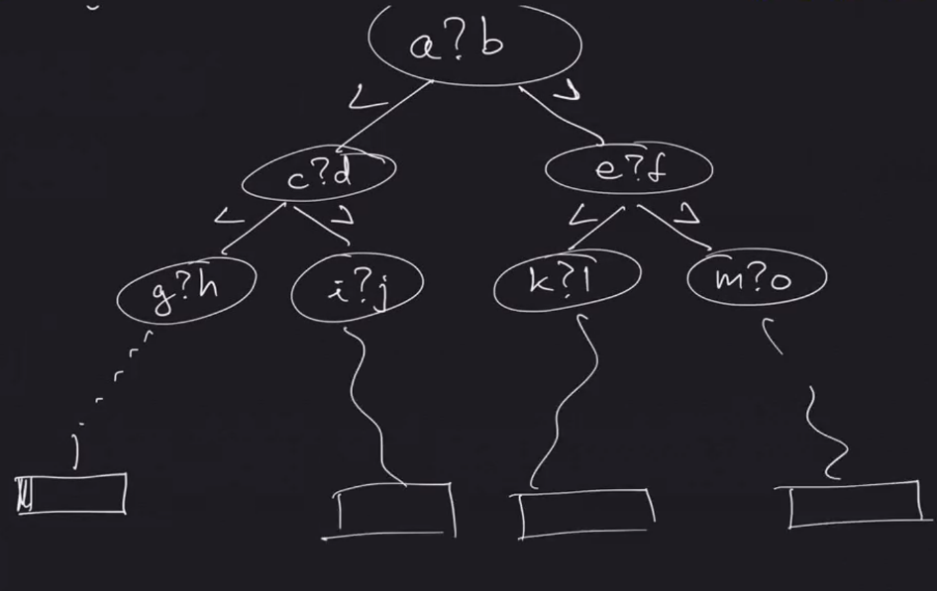

Observations:

There is only one leaf for each permutation of the input numbers (for each input, we go through one path, hence the longest possible path is the height of the tree)

The worst-case running time is the max number of comparisons (the height of the tree)

It is a binary tree, with how many leaves? As many as the number of permutations of the n items in other words.. n! leaves

NOTE: If tree has n nodes, height is lg n

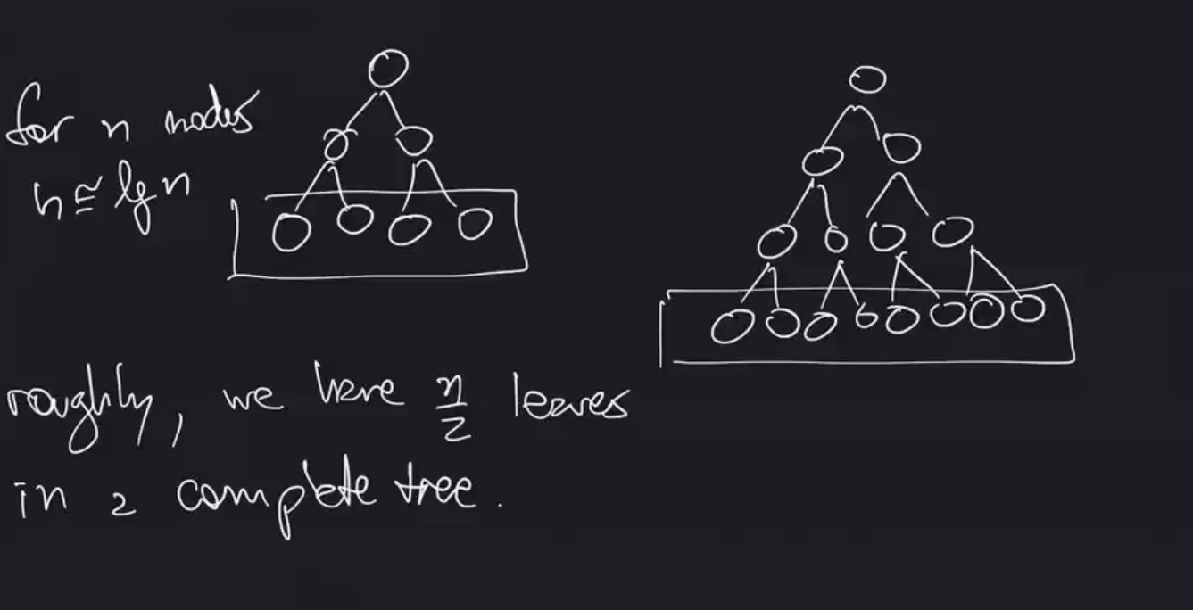

When 7 total nodes, 4 leaves in final; When 15 total nodes, 8 leaves in final

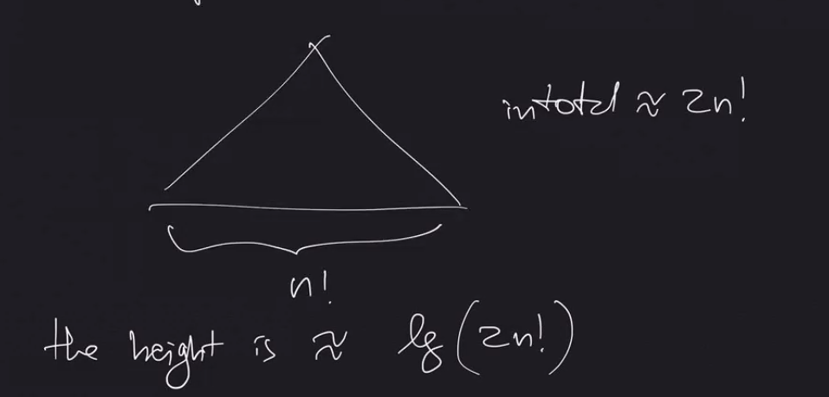

Well you might say, that’s not n lg n…. however math below:

FOR LOWER BOUND: cannot take less than n lg n

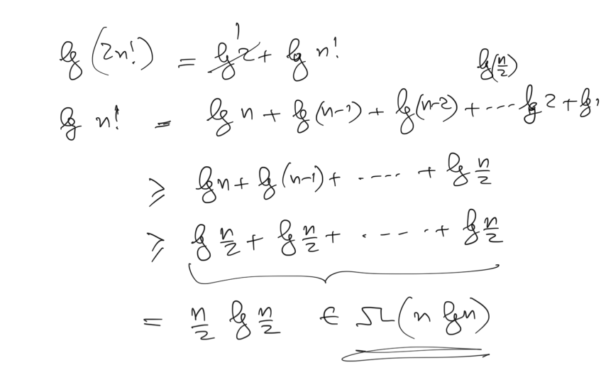

Class 8 – October 22nd

Quadratic Sorts O(n^2)

* Insertion Sort
* Selection Sort
* Bubble Sort

O(n lg n)

* Merge Sort
* Quick Sort
* Tree Sort

Comparison-based sorting for lower bound (cannot be done in less than n lg n)

* Means that merge, quick, tree sort are most optimal
* lg(n!) no less than (n lg n)

Sorting in linear time:

**Radix Sort**

* developed by IBM early 1900s (no computers back then obviously..) for population census?

Assumption:

* Items to be sorted have a max value (we know the range)
* It should not use comparisons (because it would violate the lower bound)

Example: given a set of n 1-digit numbers, possibly with repetitions, how do we sort them?

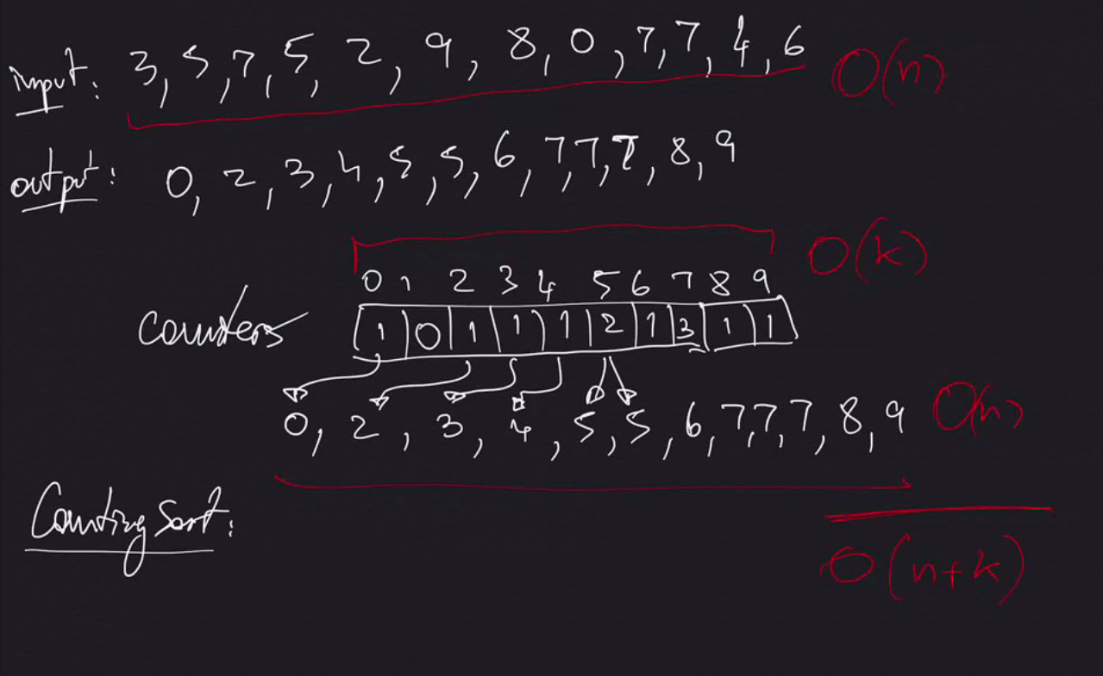

Note: If k similar to n, it is linear. If k is large number, not worth it to use radix sort (k is max number or range)

But… What if we need to be able to distinguish between multiple inputs of same value? Such as 7.1, 7.2, 7.3?

**Stable Counting Sort: Keep the repetitions in the output in the same order that were in the input**

Radix Sort must be stable

Example: Insertion Sort

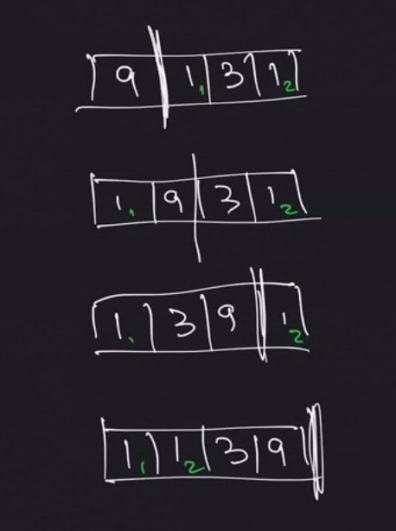

**Radix Counting Sort:** Sort by each digit, starting with the smallest / least significant number

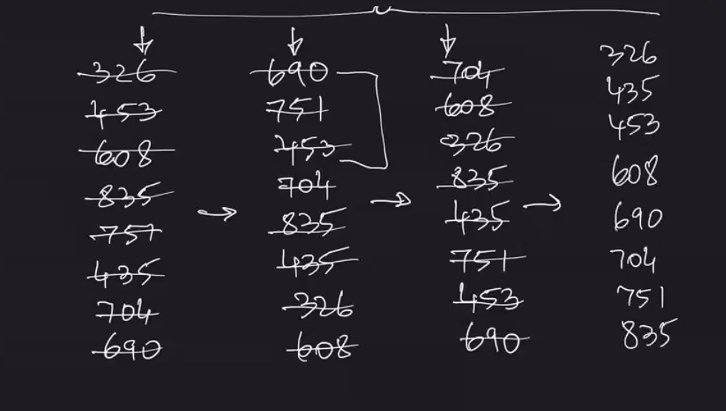

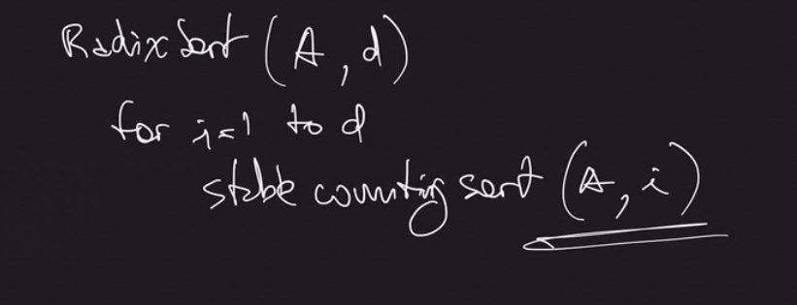

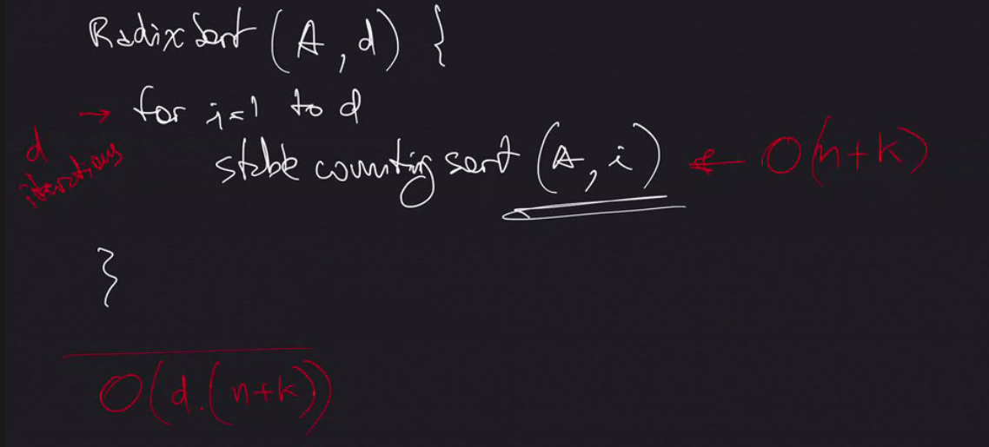

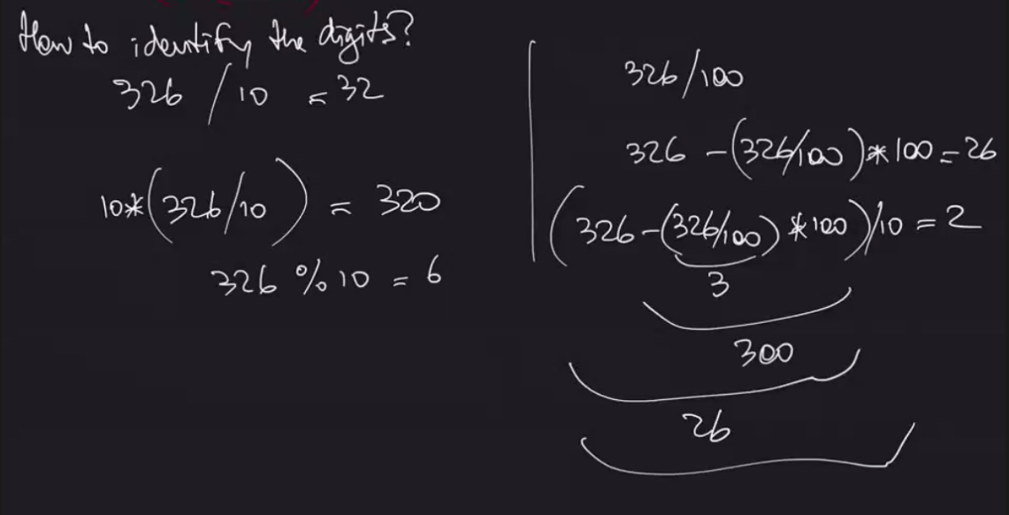

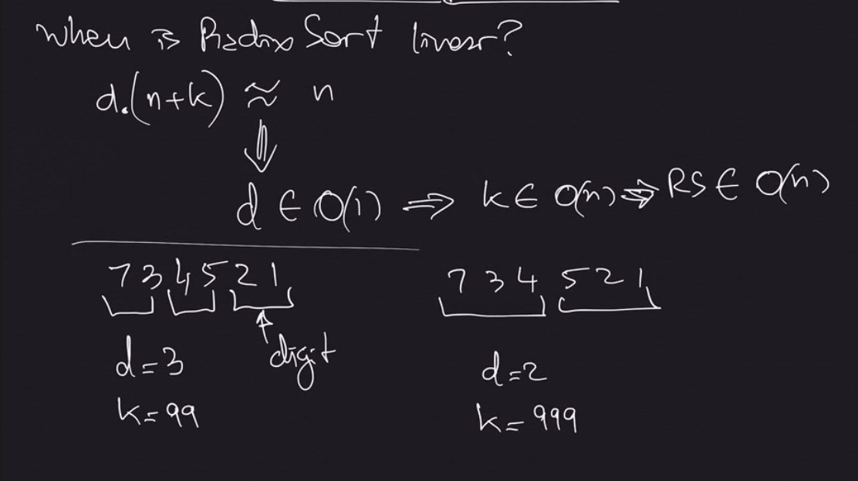

When d Is constant and k is O(n) then RS is O(n)

**Sorting Input Information**

* **Max Range -> Radix Sort**
  + Radix Sort takes advantage of knowing the maximum range (bits of each individual input – sorts each digit in order)
* **Distribution on the range -> Bucket Sort**
  + Bucket Sort takes advantage of range of the numbers in input

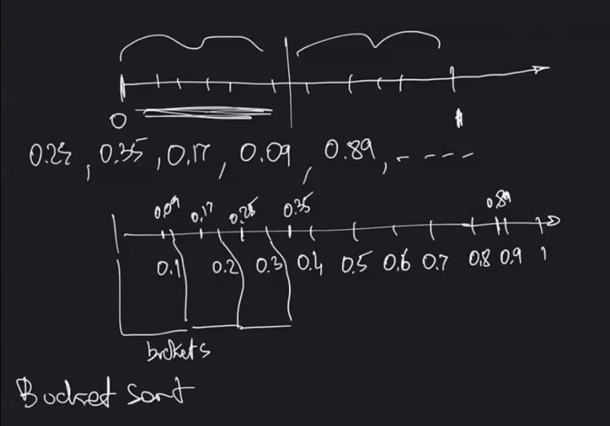

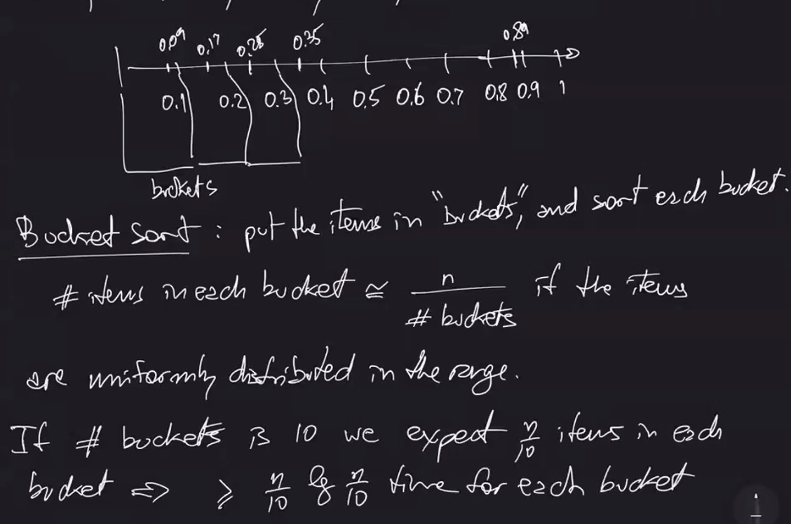

** O(n lg n)

How do we define the buckets so that sorting each bucket takes O(1)?

If distribution is uniform, divide the range in n buckets

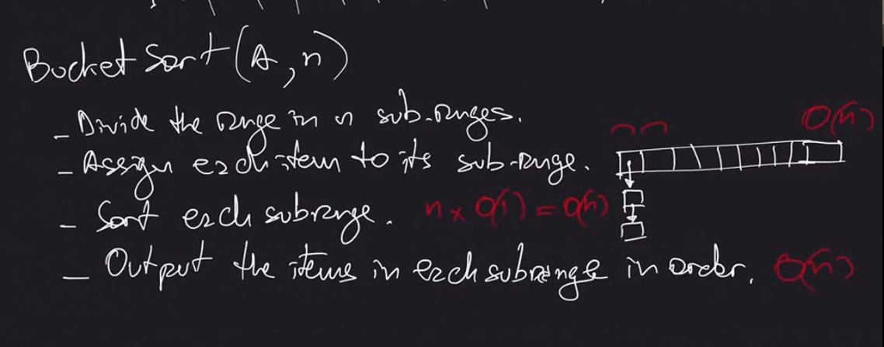

* Create an array of size n
* Each position corresponds to one of these buckets
* Need reference to list in each spot in array so we can store more than 1 in a bucket if needed
* Get first item of input, do some math operation to find which range it is in, and then we put it in the array in that list that corresponds

What if we know the distribution, but it is not uniform?

Re-define the buckets (long bucket in middle where expecting no input)

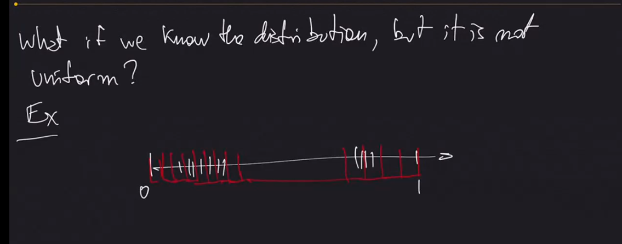

Class 9 – October 29th

Assignment 3 EC

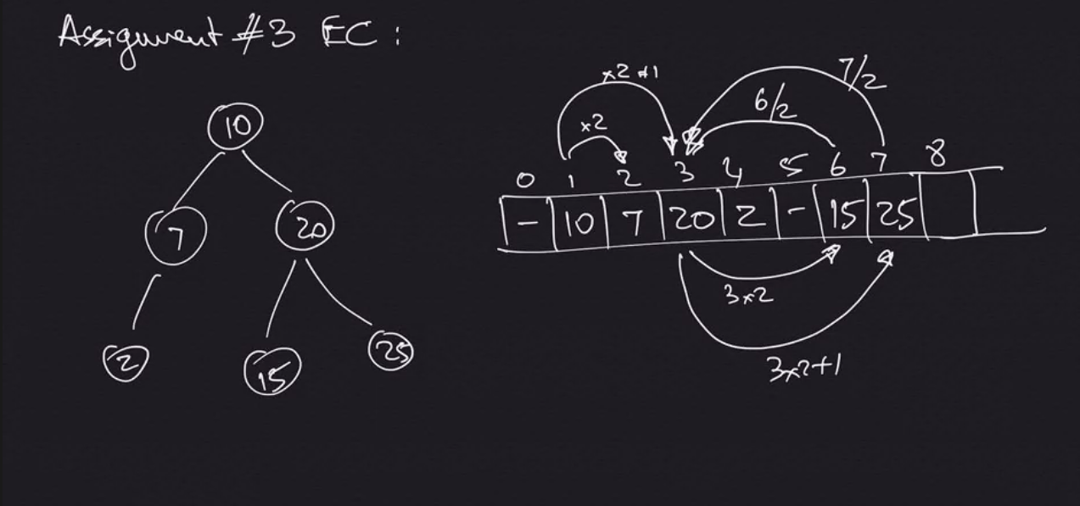

**Dynamic Programming**

“smart brute force” algorithm (brute force = try all possibilities)

If you have a problem that can be mapped similarly to one of these examples, it is probably good for dynamic programming

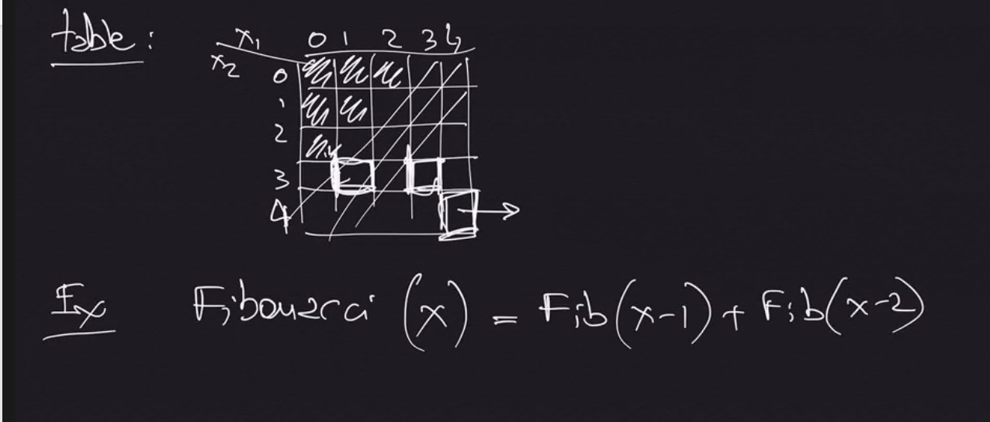

**1. Cutting Rods**

Cutting steel rods..

INPUT: a length (n) and a table of prices

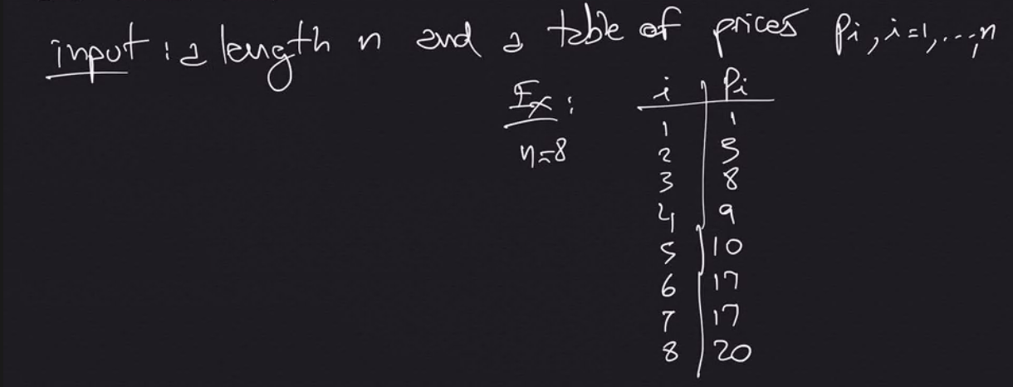

OUTPUT: The maximum revenue obtainable for rods whose lengths sum to n, computed as sum of prices of the individual rods.

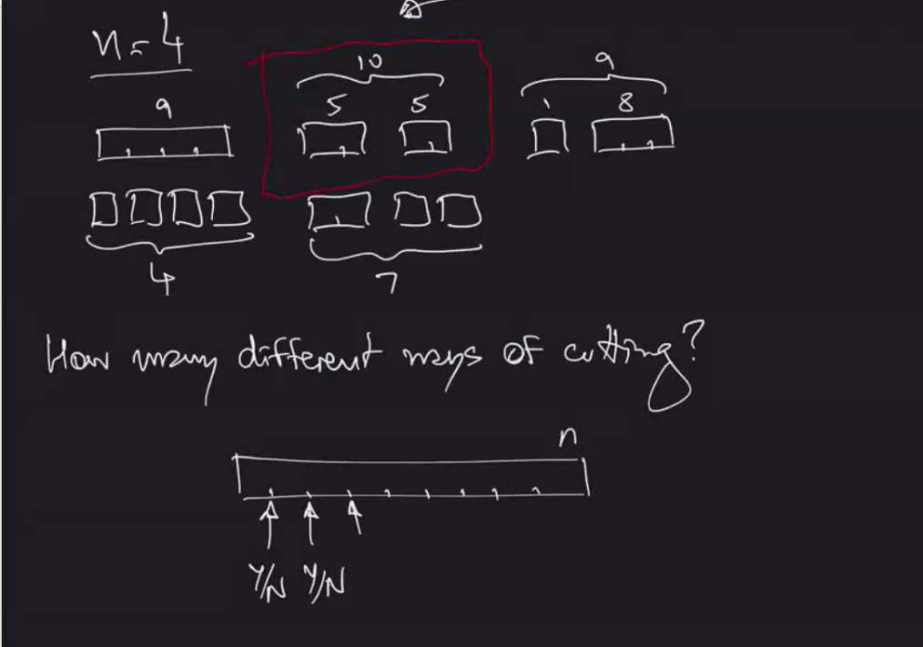

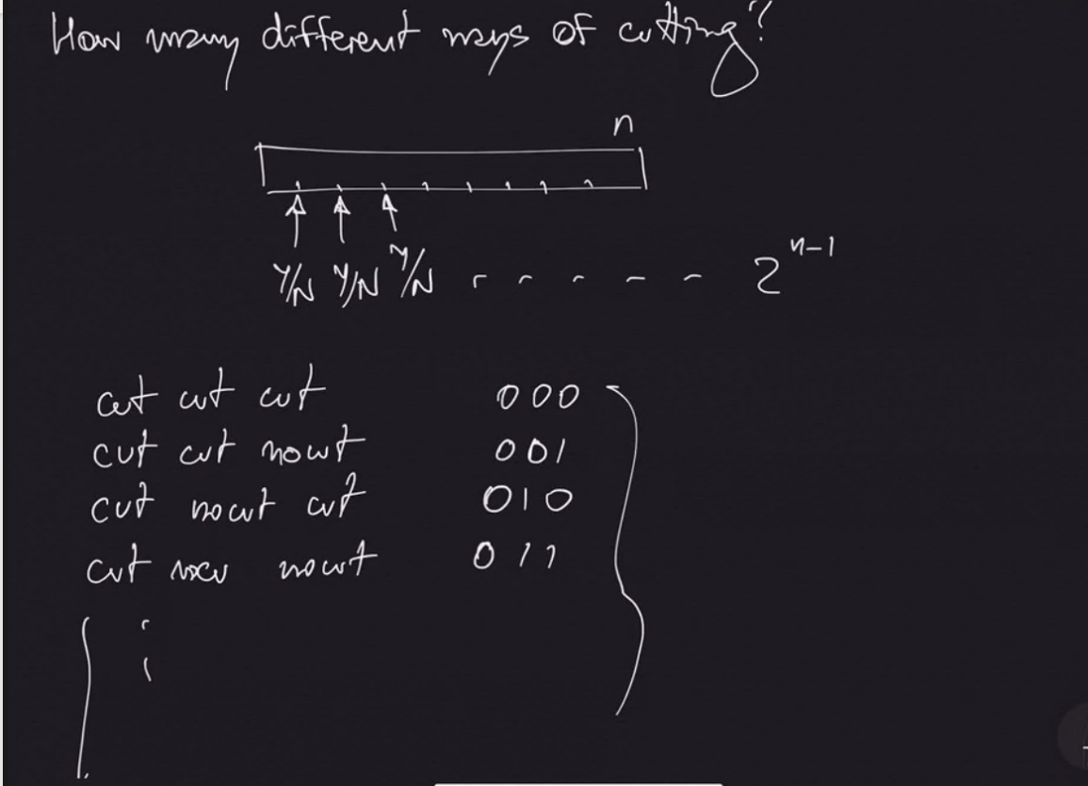

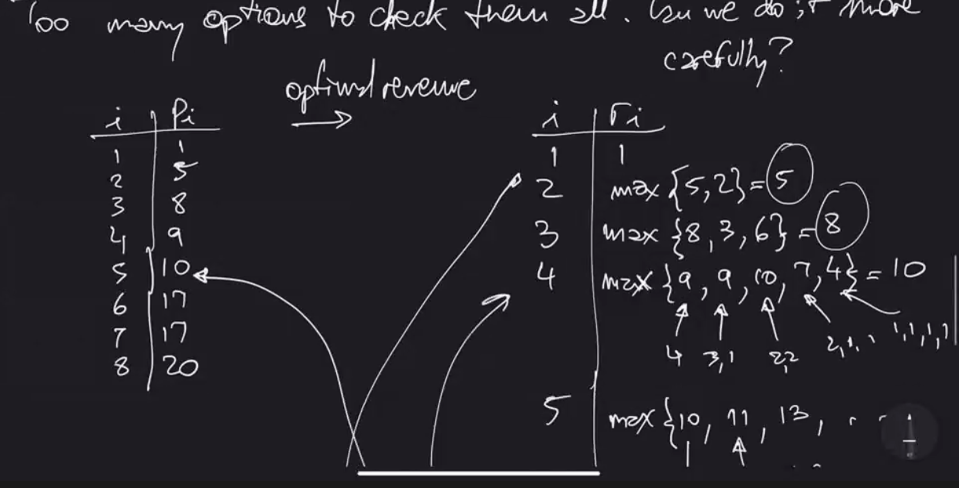

Sub Problem Optimality – Best solution for entire problem must be equal to combination of best solution for the parts in order to apply dynamic programming

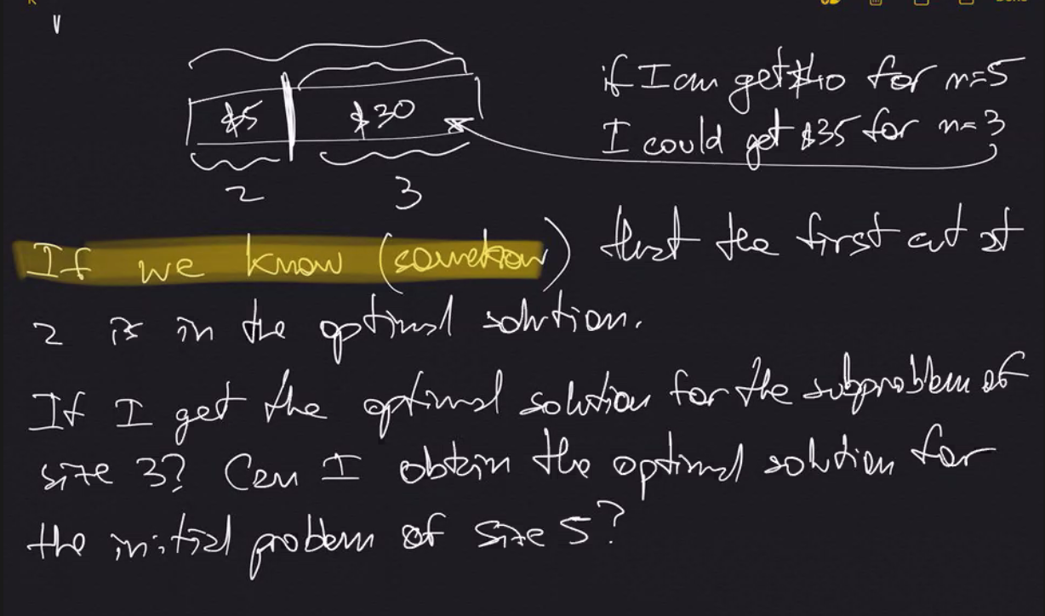

What if we do not know the first optimal cut?

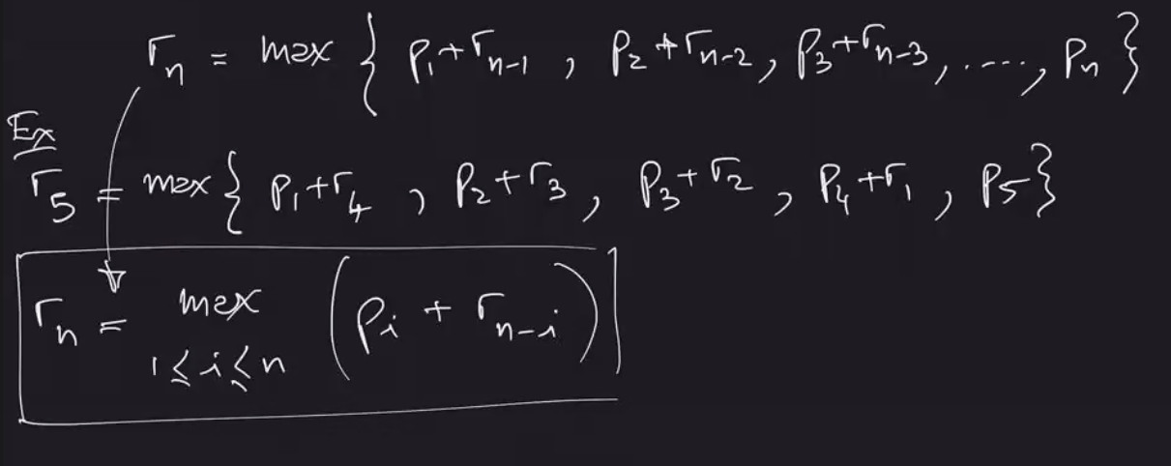

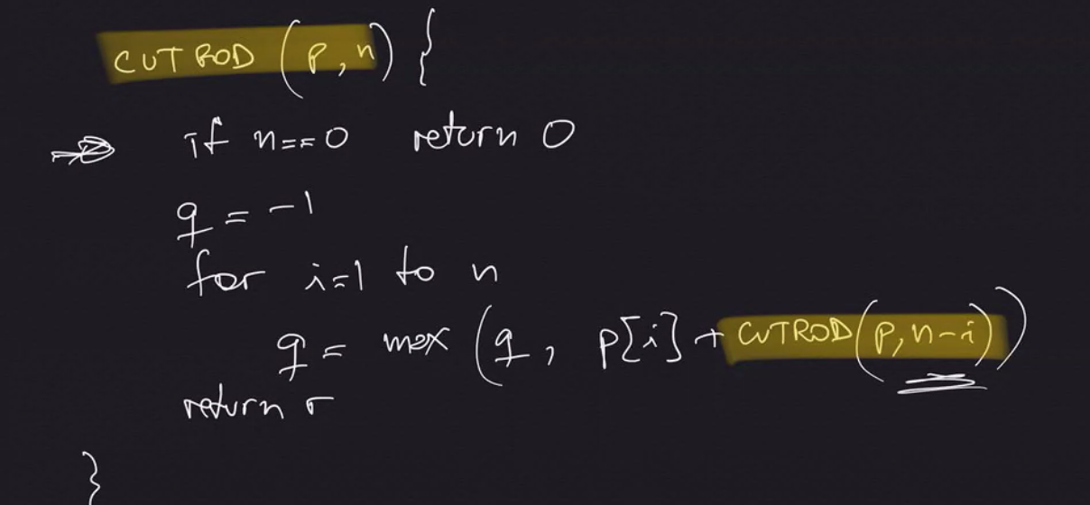

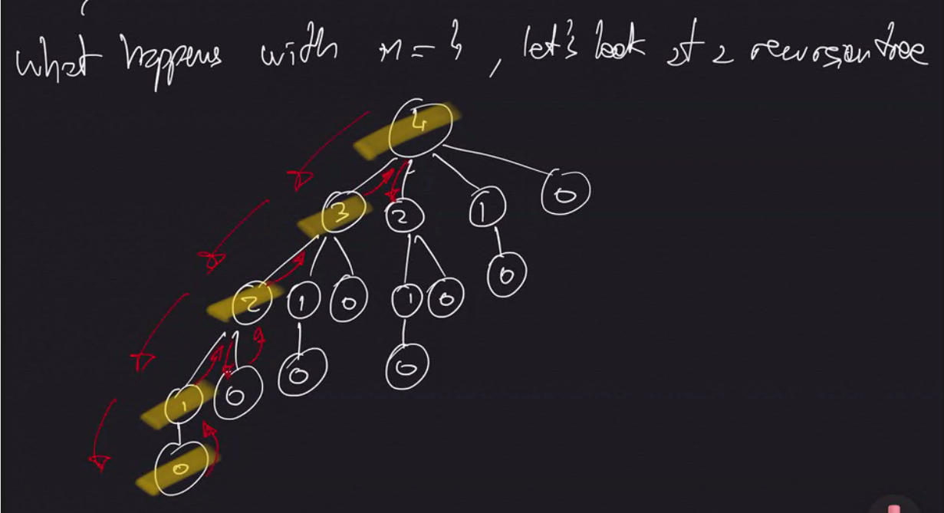

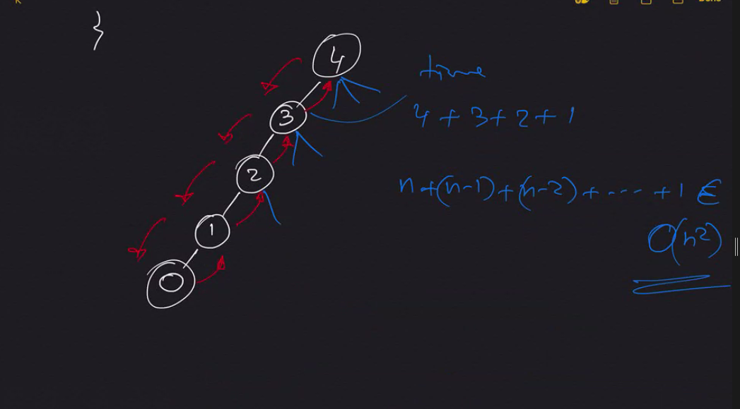

**Elementary Graph Algorithms**

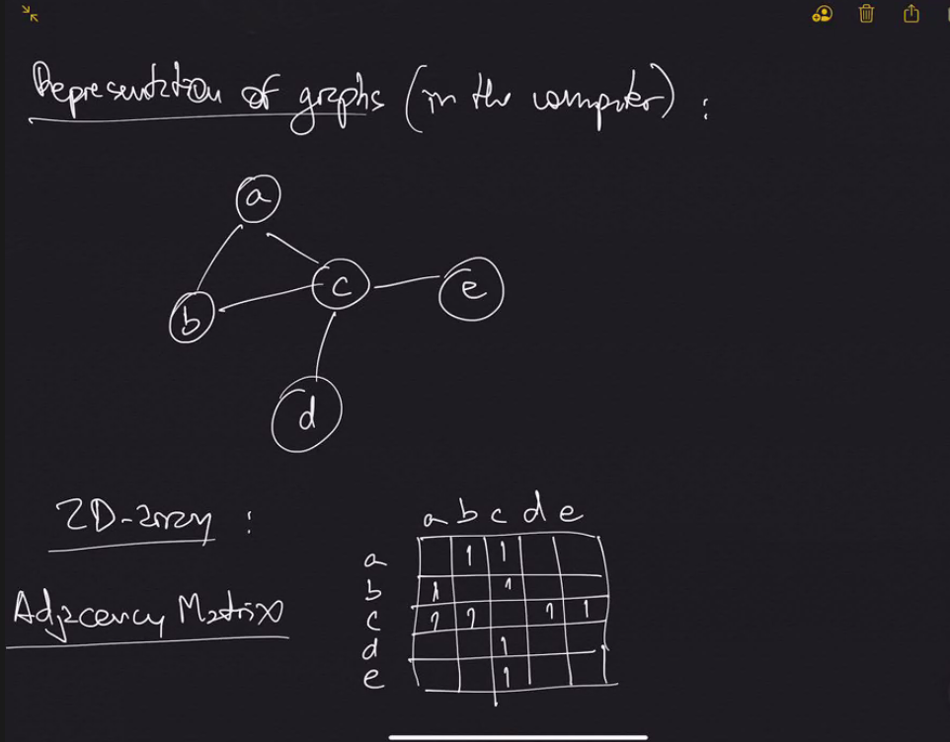

How much space? O(n^2)

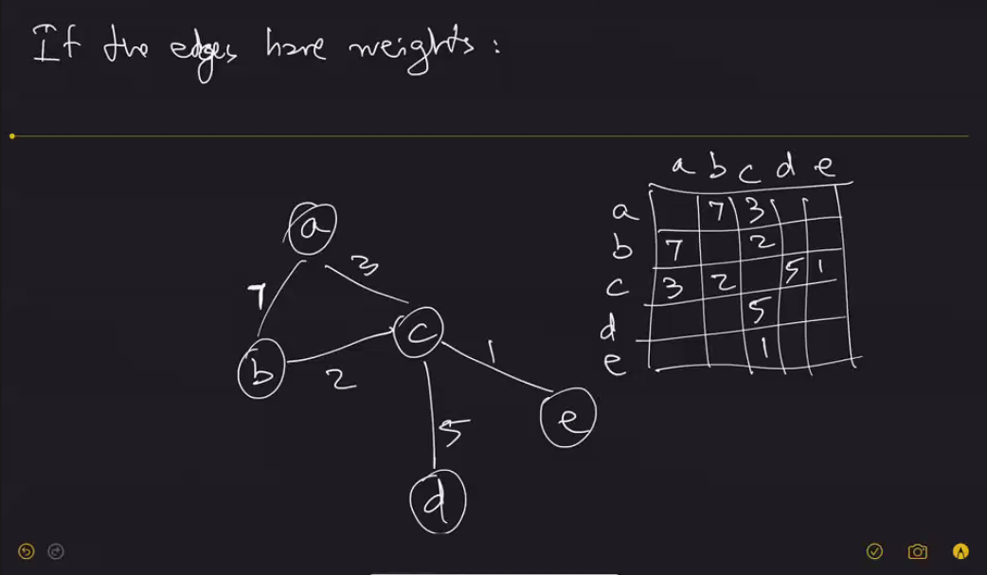

Can store colors and other attributes of nodes in a different array (screenshot from notes)

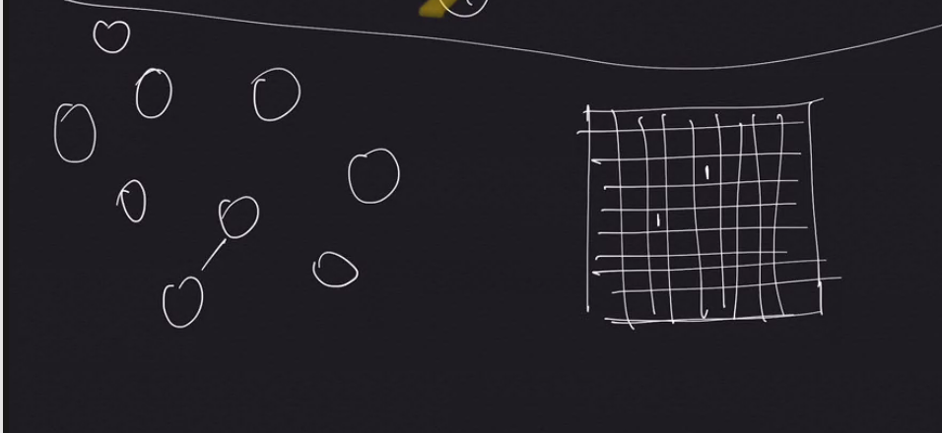

This seems like a waste of space to use Adjacency Matrix when only 1 connection. Instead use Adjacency List.

**Adjacency List:**

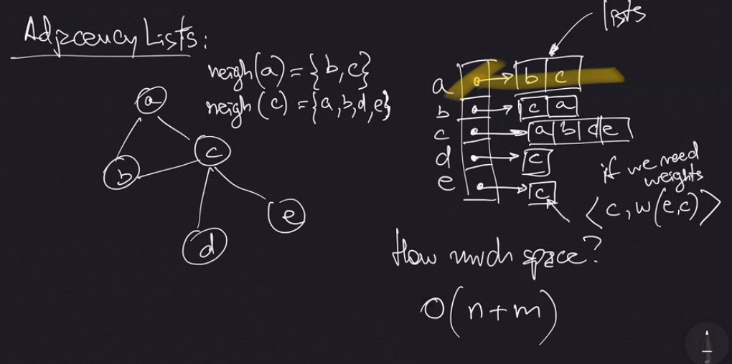

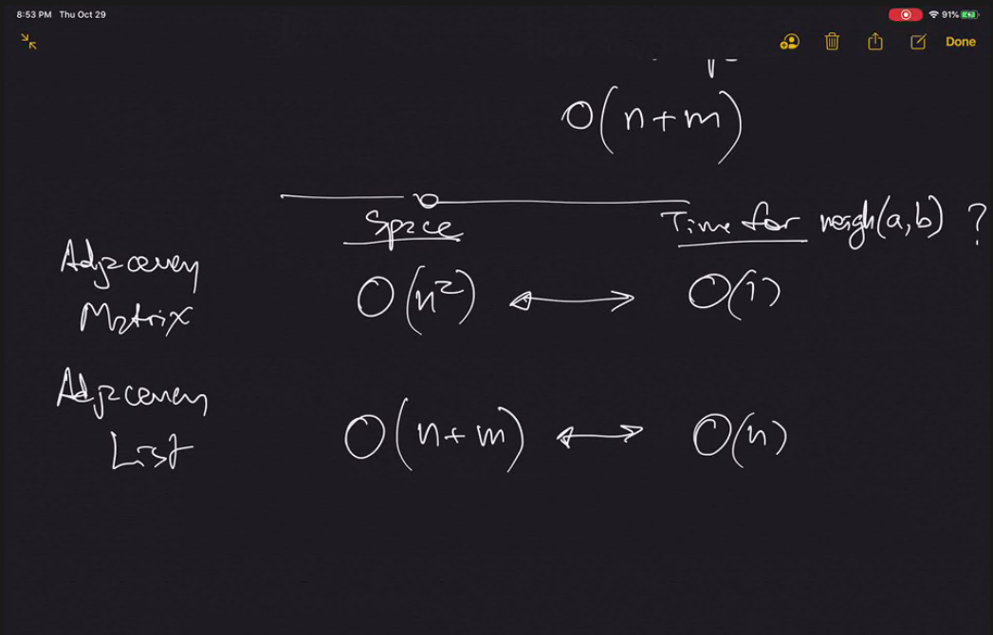

Class 10 – November 5th 2020

Adjacency Matrix

* Usually stores true/false for whether a connection is present (see picture 2 pages above - 38)
* Stores other attributes in separate arrays (such as colors)

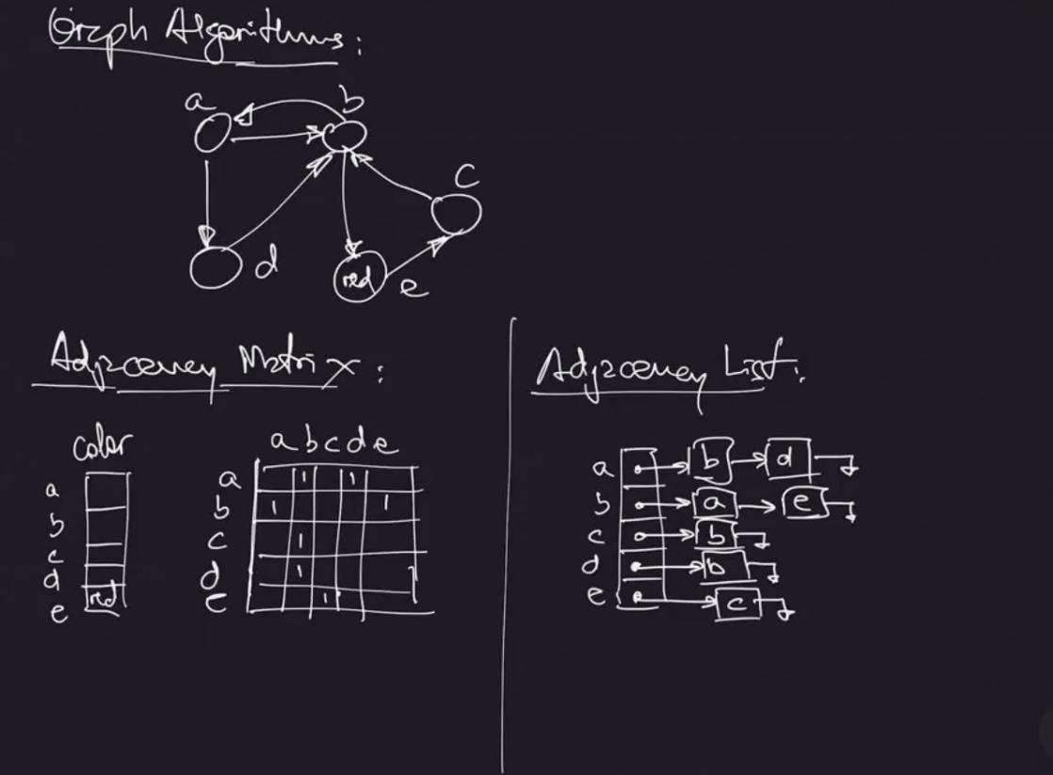

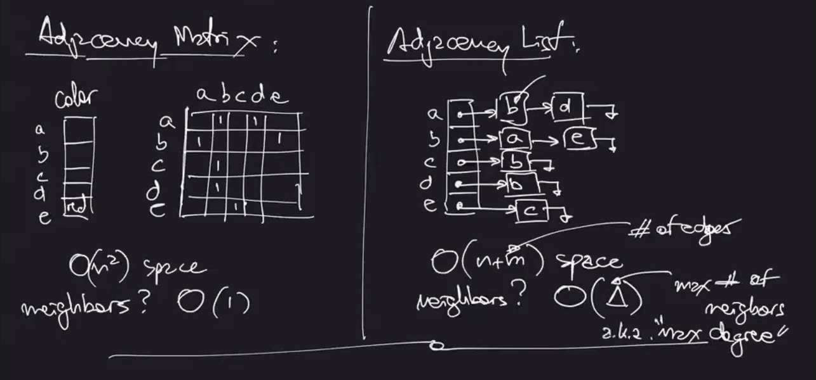

**Depth First Search – As long as we can go to a neighbor that has not been visited yet, we do it.**

Outputting each node after reaching it for first time

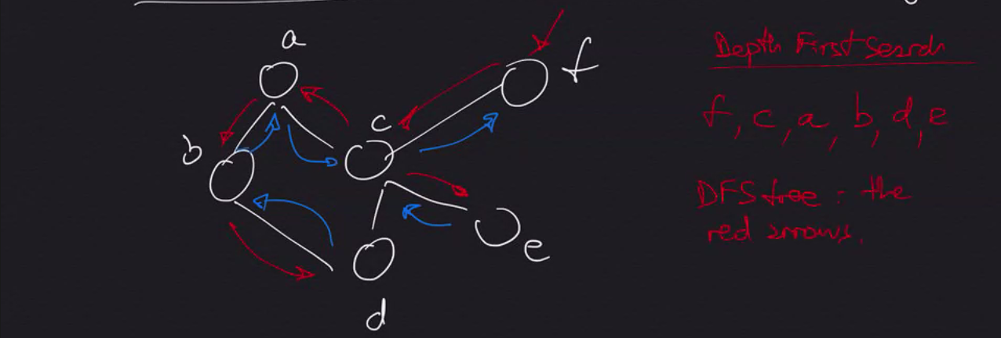

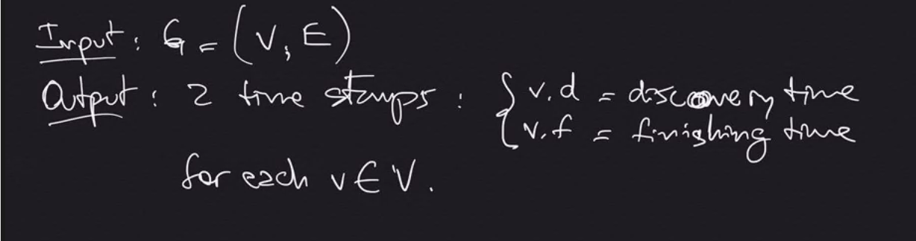

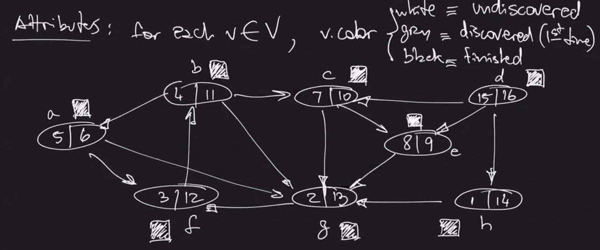

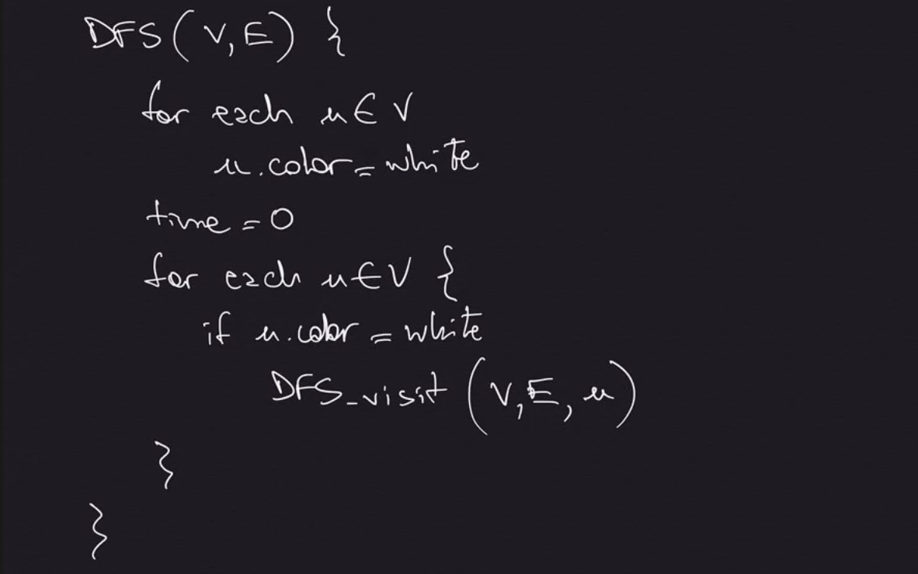

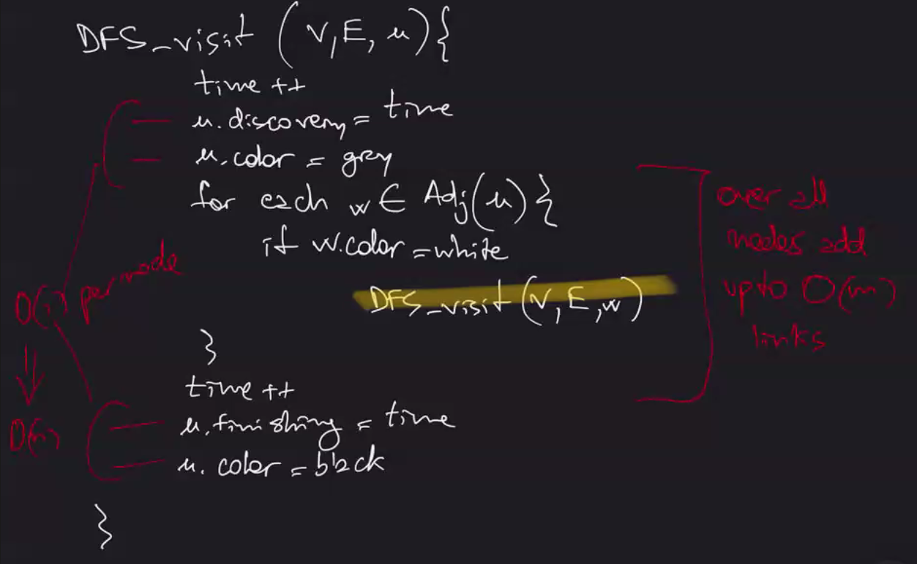

O(n+m) – Big O will take care of which ever one is bigger (if G is stored in an adjacency list)

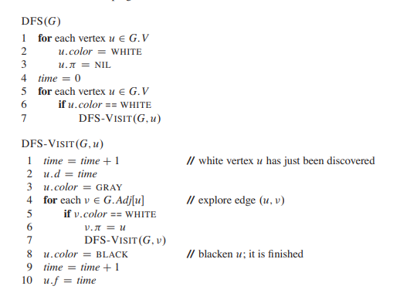

**Breadth First Search – Go to all of the neighbors before going to neighbors of neighbors. One level at a time. Distance away from starting node is important (infinity if not connected) – (2:18 AM 11/5)**

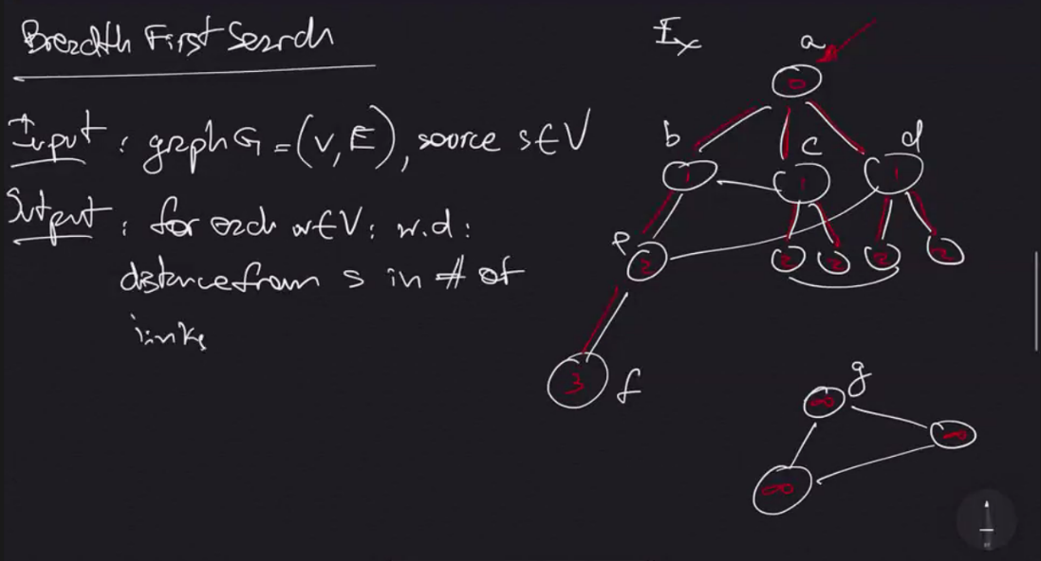

**Queue is a data structure with operations enqueue() and dequeue() that maintains a First In First Out (FIFO) order.**

w = neighbor

s.d = distance from source

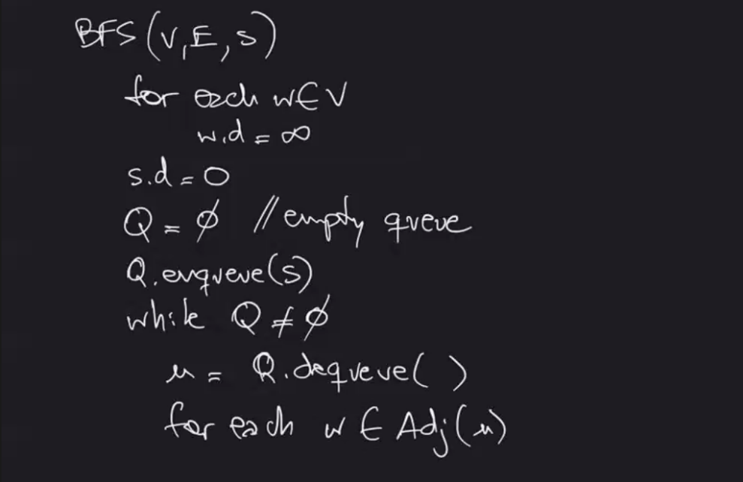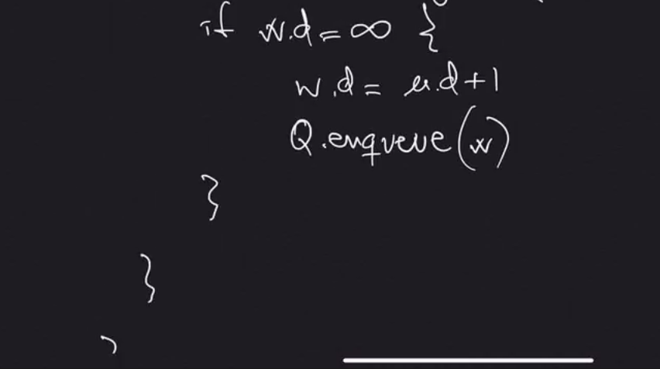

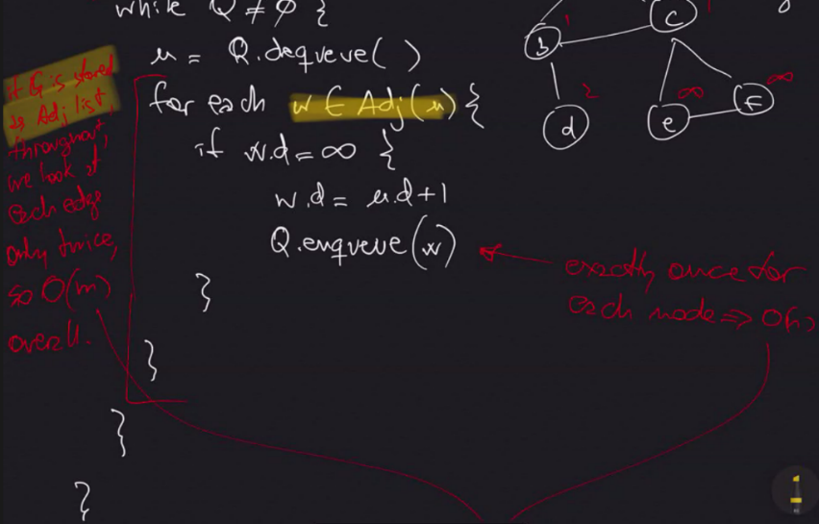

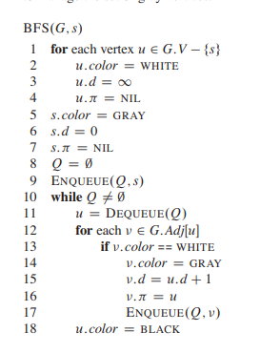

**Class 11 – November 12th**

Making Change

Input:

* Amount x dollars
* d [0…n] coin denominations

Output: minimum number of coins needed to make change out of x

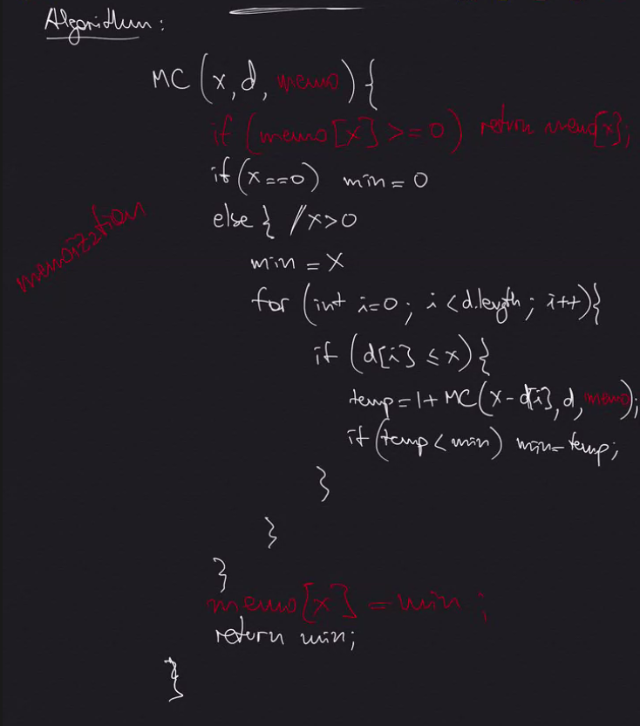

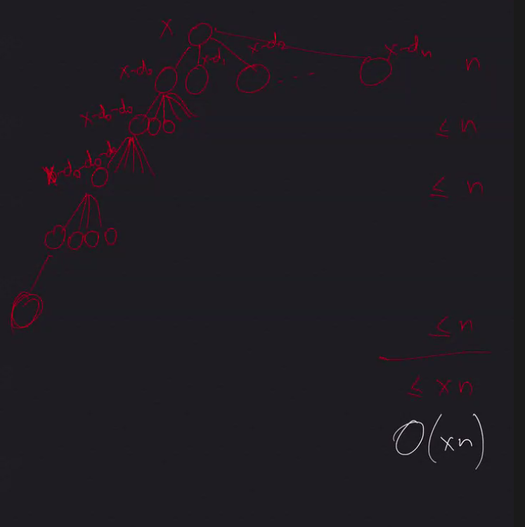

Graph Algorithms

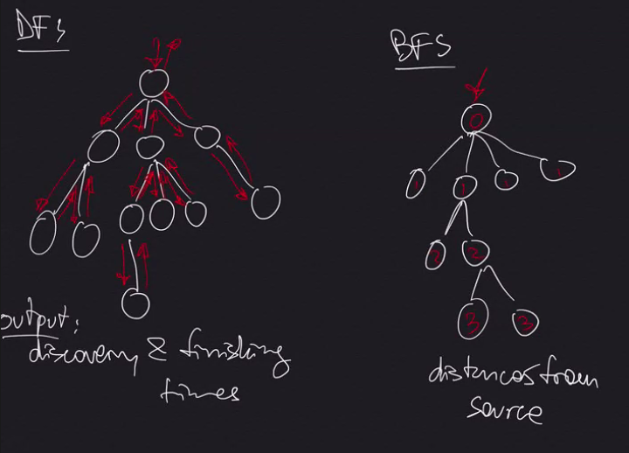

With adjacency list, O(n+m)

**Topological Sort: (**[**https://www.geeksforgeeks.org/topological-sorting/**](https://www.geeksforgeeks.org/topological-sorting/)**)**

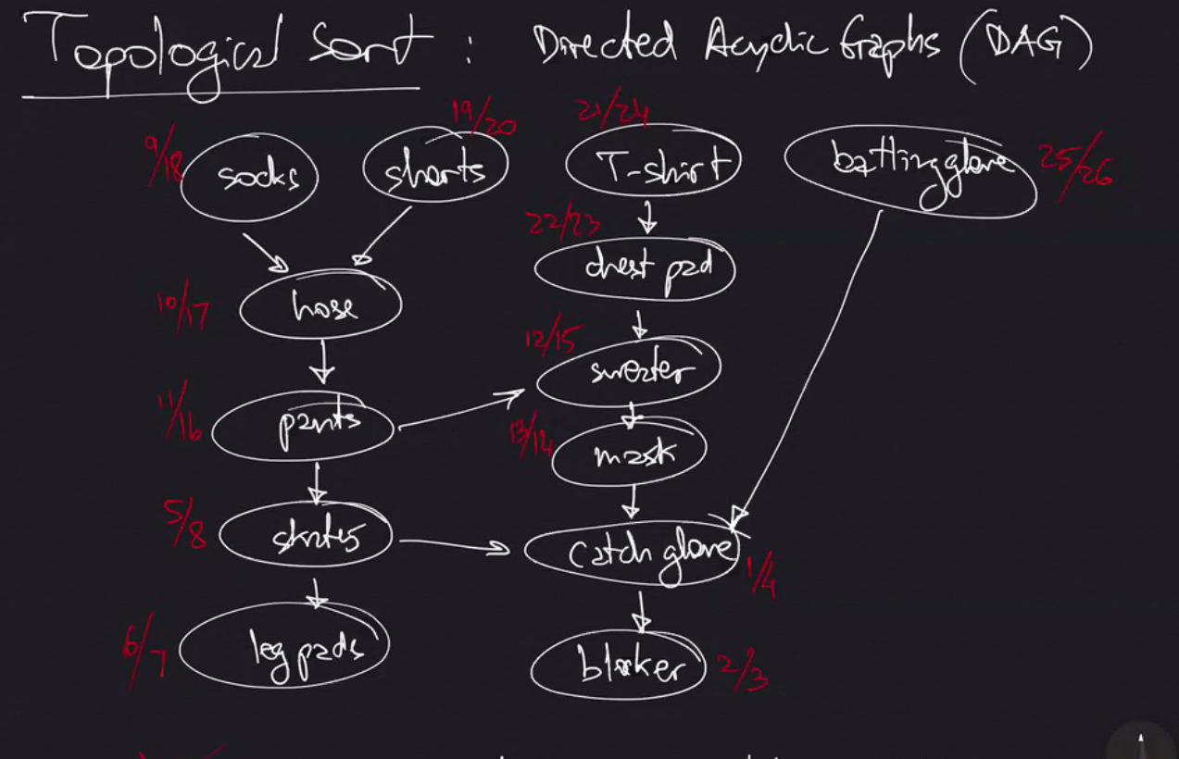

Decreasing Finishing Times of DFS = Topological Sort

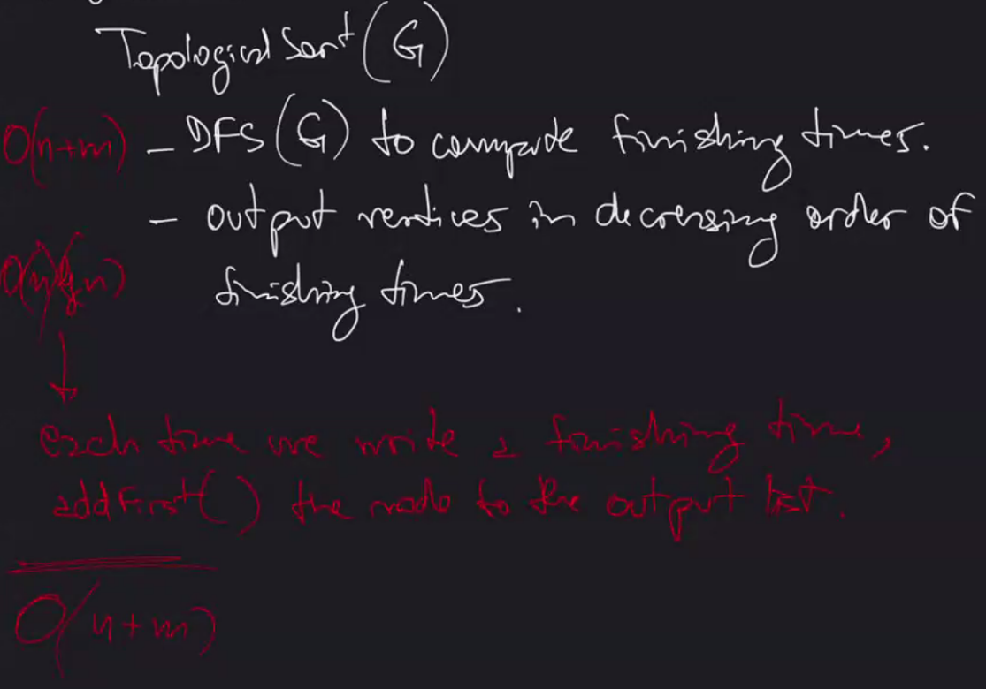

O(n lg n) for outputting in decreasing order can be skipped by adding nodes to output list during the DFS, therefore just O(n+m)

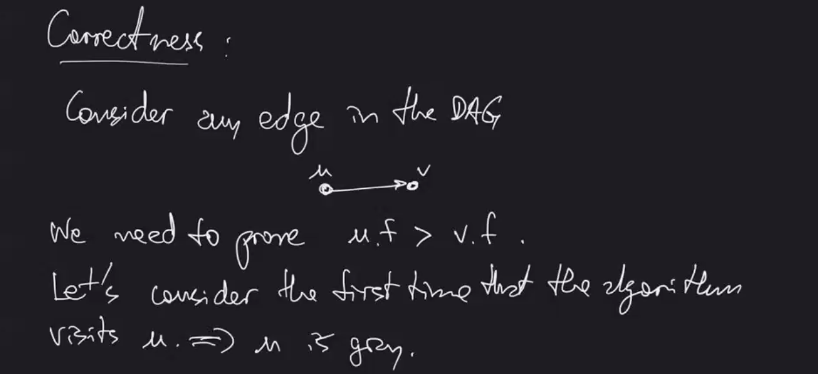

Proof:

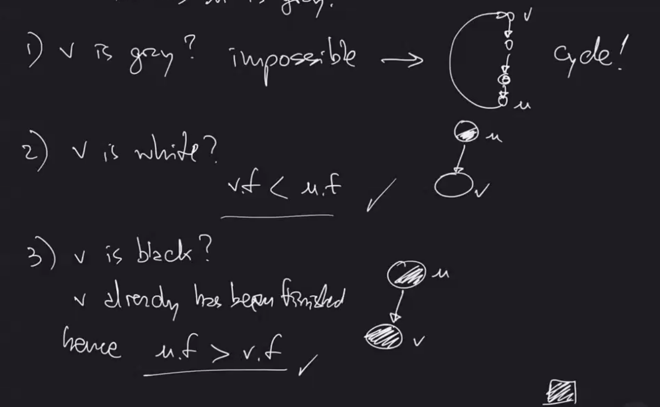

**Strongly Connected Components: (missed a few screenshots, go check notes)**

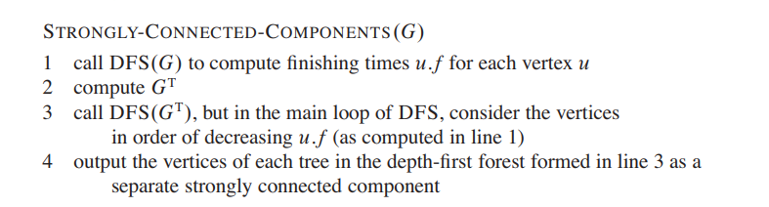

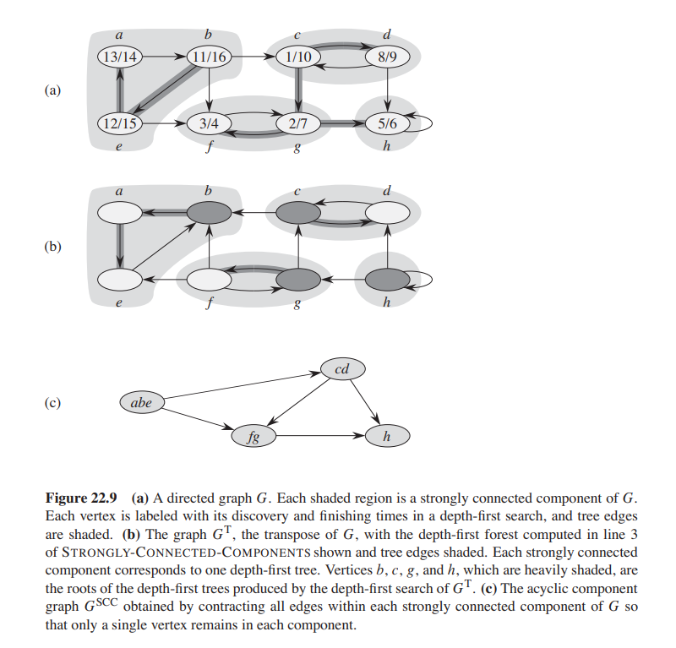

Input: a directed graph, G

Output: A partition of the set of nodes such that for each subset, every pair of nodes is connected in both directions

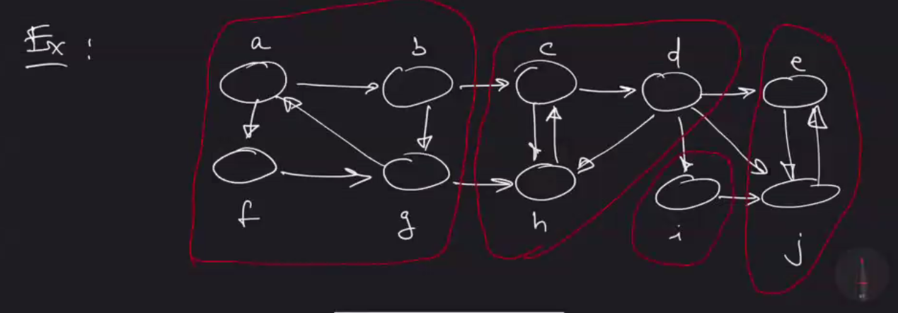

Component Graph:

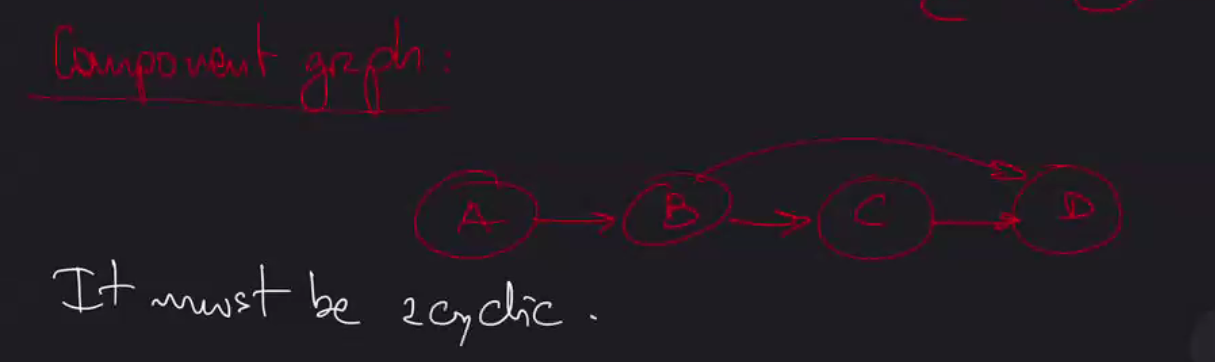

How to know start/end of each component though?

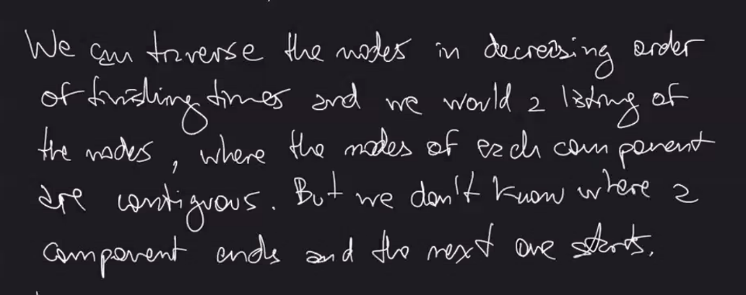

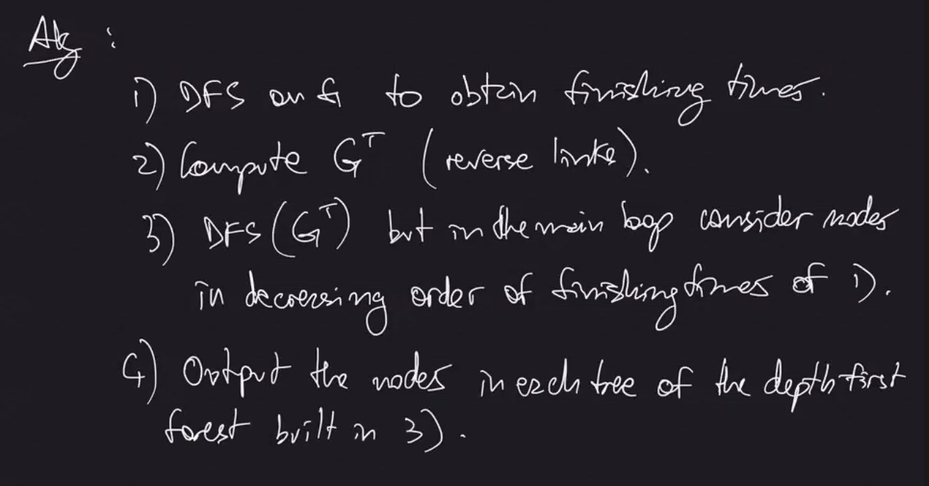

Correctness: by the fact that the SCC(G) are the same as SCC(G^T) (T = transposed, or flipped directions)

**Class 12 – November 19th**

Minimum Spanning Trees (ch 23)

Kruskal’s Algorithm:

1. Sort all edges by weight
2. For each edge in that order, if it does not form a cycle, add it to the tree

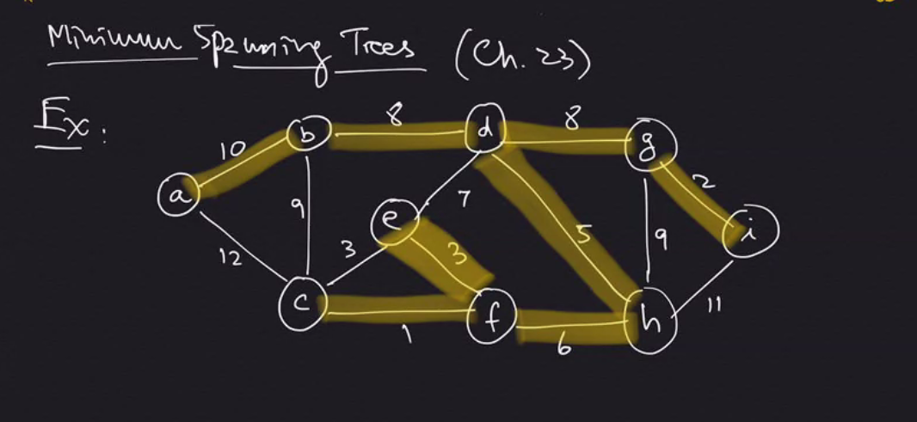

Correctness:

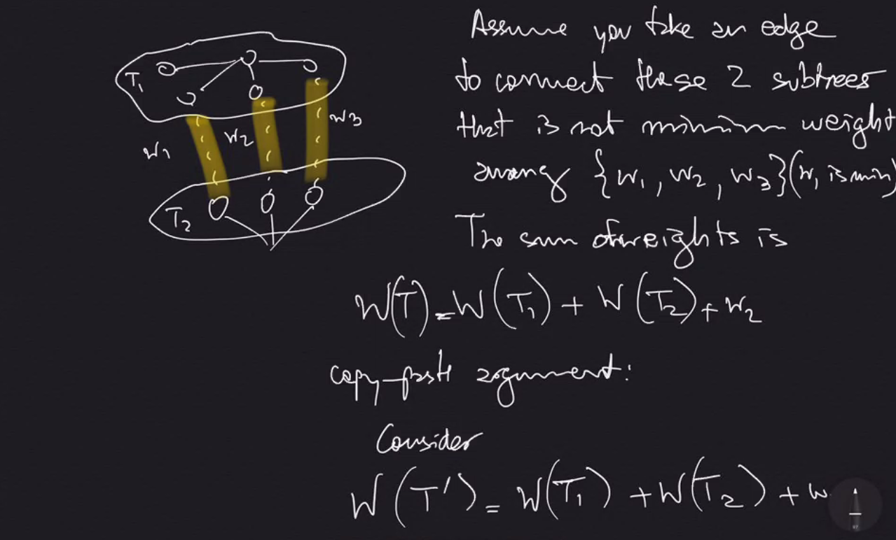

Copy Paste argument – shows that using smaller weight (w1) would lead to smaller overall weight.



We can use Union-Find (aka Disjoint Sets) Data Structure

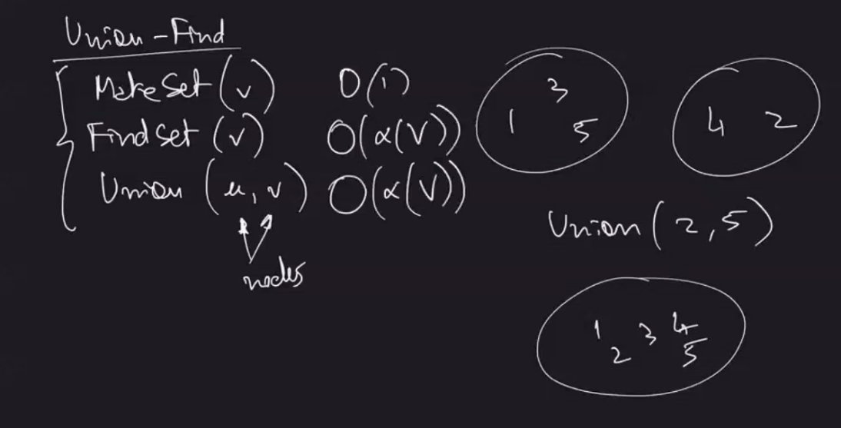

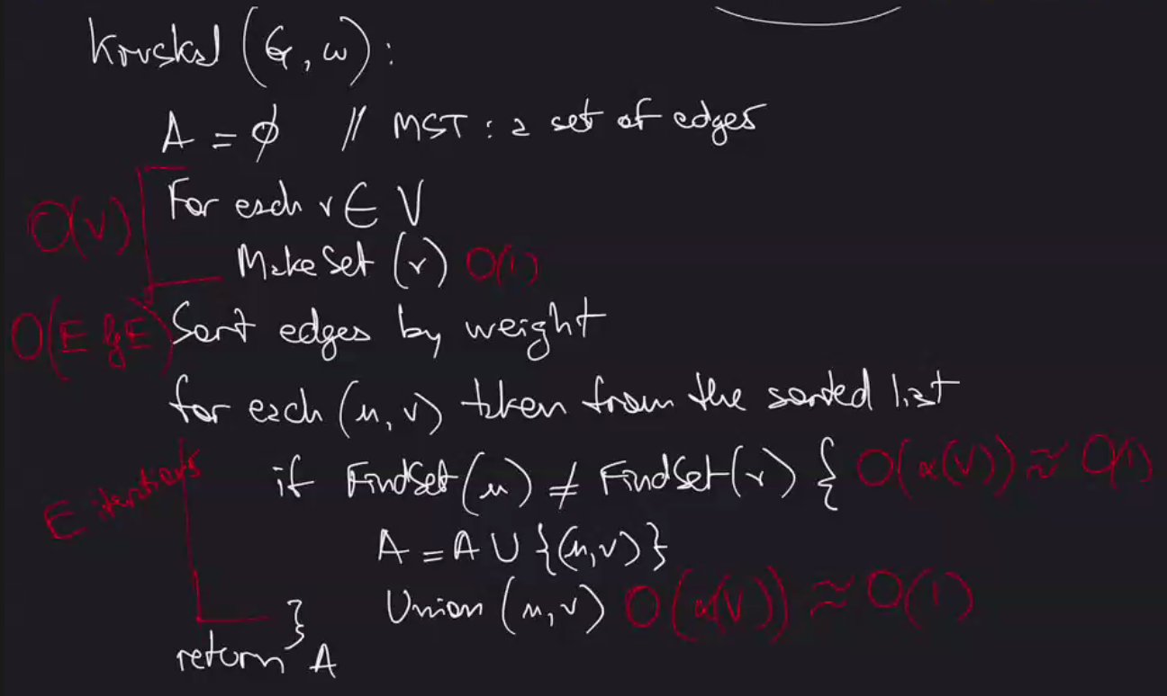

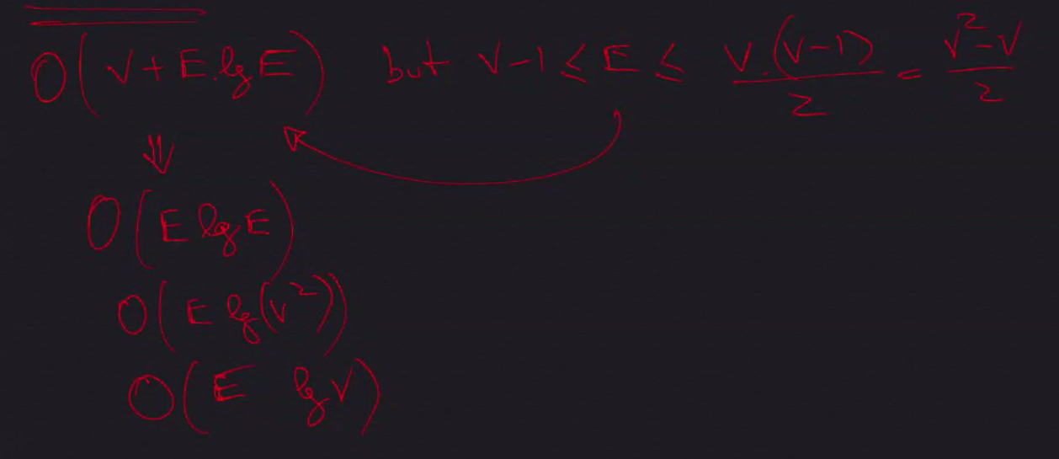

O (E lg (V^2)) 🡪 O (E 2 lg V) 🡪 O (E lg V) REMOVE constant 2

PRIM’S ALGORITHM: (same run time O (E lg V)

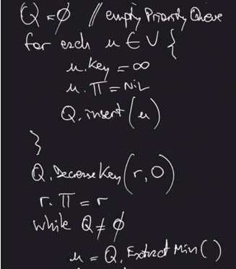

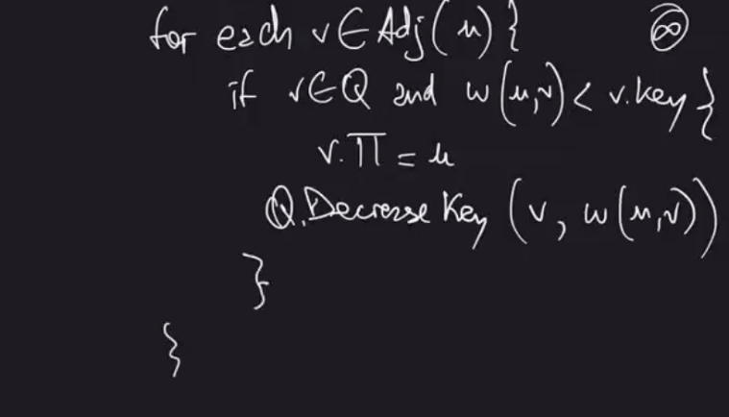

Pi symbol = Parent

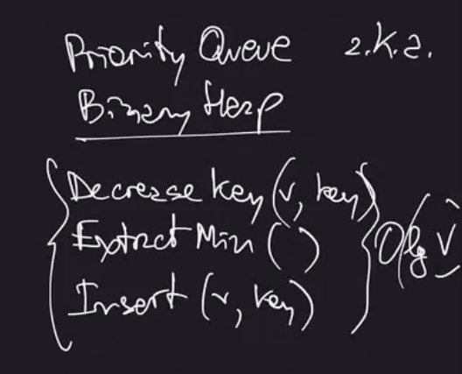

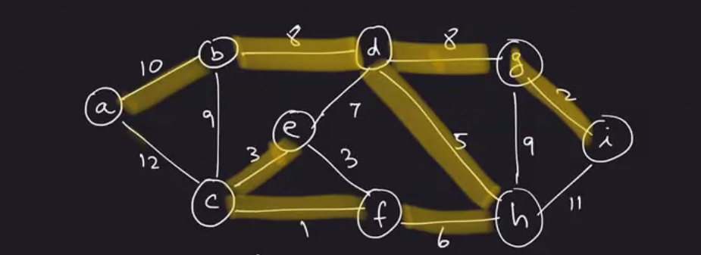

Single-Source Shortest Paths (ch 24) – How to find the shortest route between two nodes

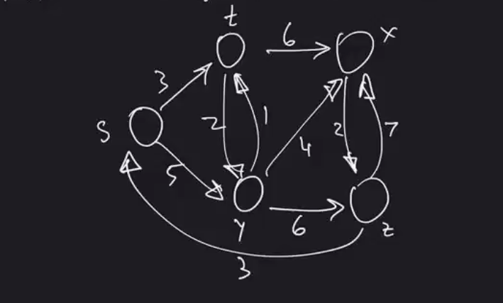

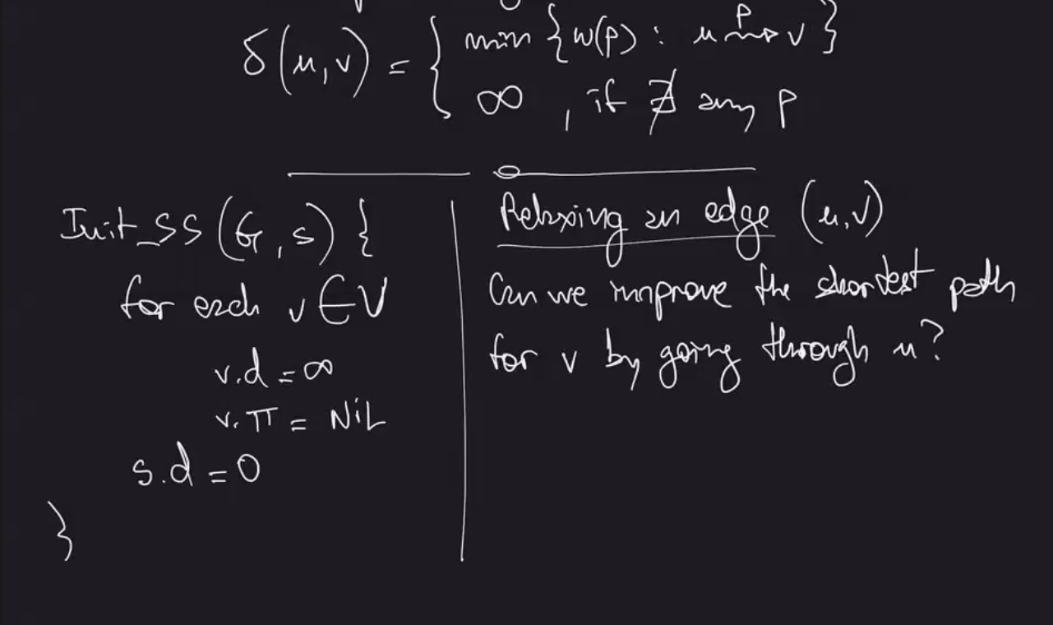

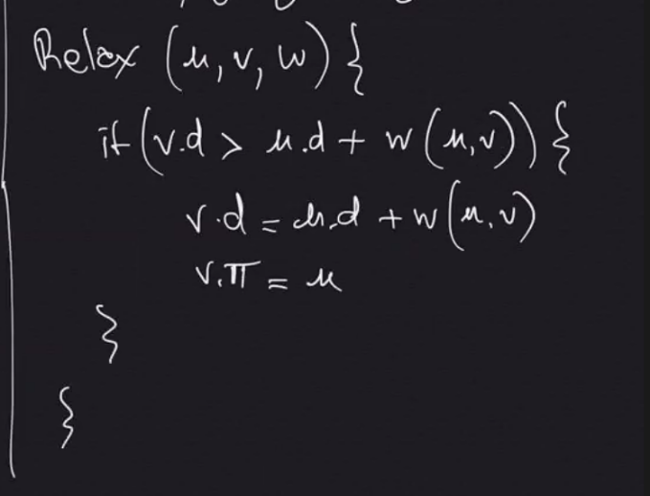

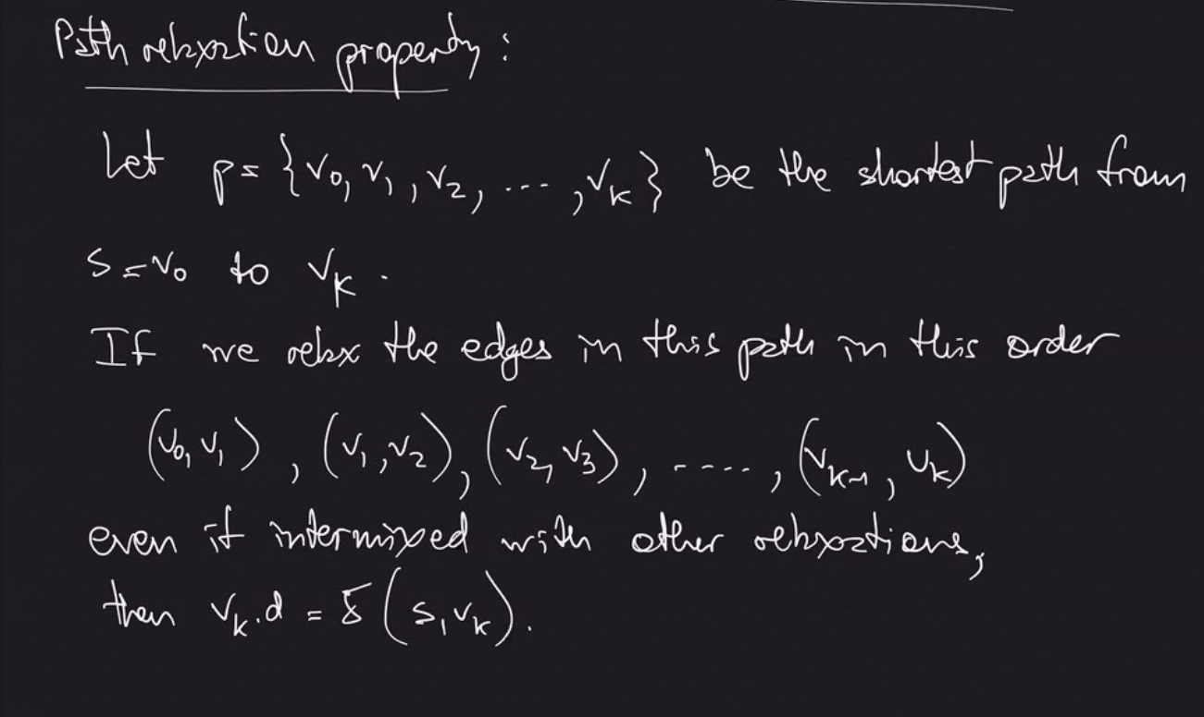

(delta)

In other words: if we relax in the order of shortest path, we will get the shortest distance to that node

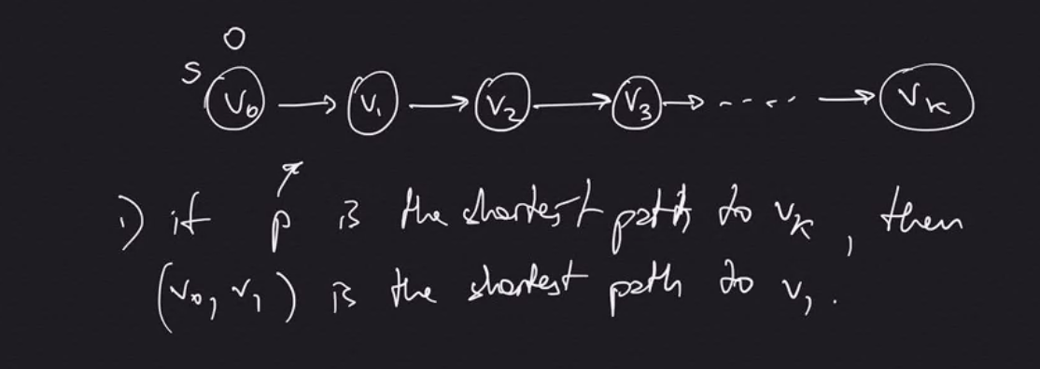

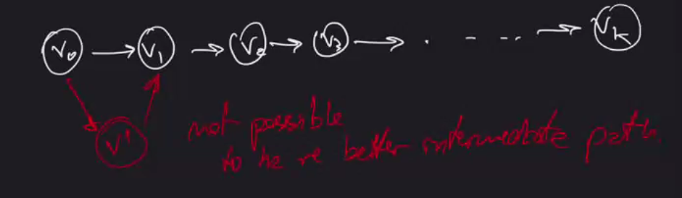

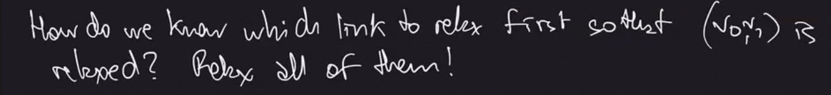

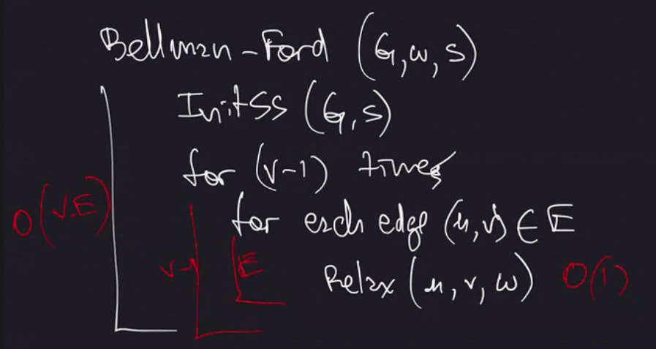

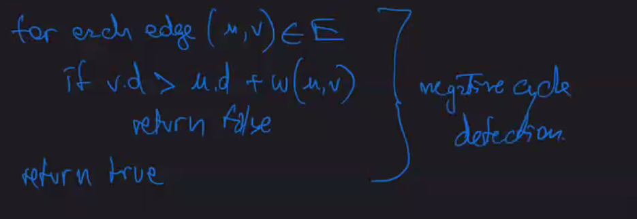

Belliman-Ford detects negative cycles and negative edges. (Dijkstra’s Algorithm does not, but it achieves better run time if it has no negative cycles)

Dijkstra’s Algorithm (no negative weight edges):

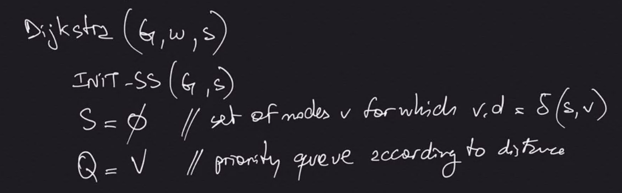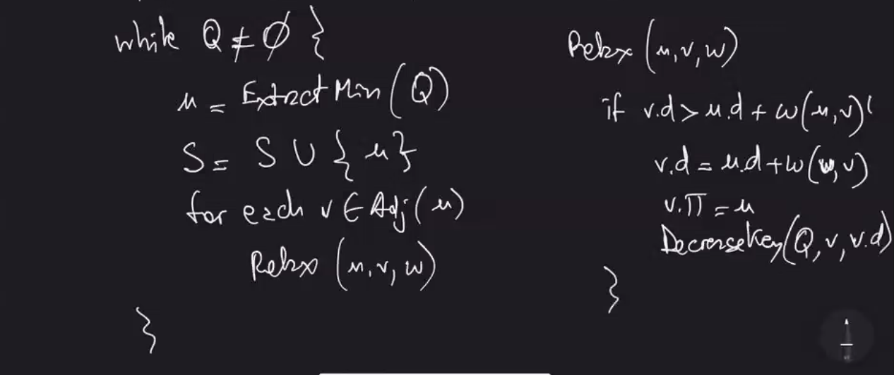

Video Example 2:55 AM

O (E lg V)

FINAL REVIEW:

Week 7 Sorting (Ch 6 & 7)

* Merge Sort
* Heap Sort
* Quick Sort

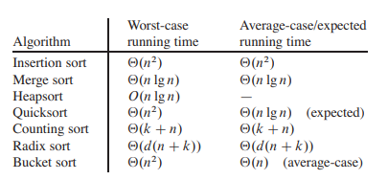

Week 8 Sorting in Linear Time (Ch 8)

* Lower bound for comparison sort
* Counting Sort
* Radix Sort
* Bucket Sort

Week 9 Dynamic Programming (Ch 15)

* Rod Cutting
* Longest common subsequence
* Optimal binary search trees

Week 10 Graph Algorithms (Ch 22)

* Data structures for graphs
* DFS
* BFS
* Topological Sort
* Strongly Connected Components

Week 11 Minimum spanning trees (Ch 23)

* Kruskal
* Prim

Week 12 Shortest Paths Algorithm (Ch 24)

* Bellman-Ford
* Dijkstra

Harvard CS50:

Locker Example

LINEAR SEARCH

7 lockers, open each locker from left to right to see if 0 is present

Upper bound – Big O(n) – Worst case scenario (what really matters)

Lower bound – Omega(1) ---- If 0 was present in first locker (best case scenario)

Theta – used if lower bound and upper bound are same answer (not in this case)

**Binary search** – telephone book example – sort, then start in middle and get rid of the half you don’t need

Upper bound – O(log n)

Lower bound – O(1)

O(n^2)

O(n log n)

O(n)

O(log n)

O(1)

**Selection Sort O(n^2)**

For I from 0 to n-1

Find smallest number between numbers[i] and numbers[n-1]

Swap smallest number with numbers[i]

n + (n-1) + (n-2) + …. + 1

n (n + 1) / 2

(n^2) / 2

n^2 / 2 + n / 2

O (n^2) -- got here by reducing to only the most significant pieces

**Bubble Sort O(n^2)**

Repeat n-1 times

For I from 0 to n-2

If numbers[i] and numbers[i+1] are out of order:

Swap them

If no swaps

Quit (optimization that allows for lower bound to be omega N in best case)

(n-1) x (n-1)

n^2 – 1n – 1n + 1

n^2 – 2n + 1

O(n^2)

**Merge Sort O(n log n)**

If only one number

Quit

Else

Sort left half of numbers

Sort right half of numbers

Merge sorted halves

O (n log n) – shelves in harvard video. Log n height (3 shelves) and n numbers on each shelf

Omega (n log n) – have to do entire process anyway

Therefore, Theta (n log n) because O and lower and upper bounds the same

Harvard CS 50 Lecture 5 – Data Structures

O(n^2)

O(n log n)

O(n) - insert

O(log n) – search (binary)

O(1)

Omega(n^2)

Omega(n log n)

Omega(n)

Omega(log n)

Omega(1) – search, insert

**Linked List (takes more memory than array bc needs space for pointers)**

Array – memory is contiguous

List – memory not necessarily contiguous

Linked List – list with a memory space for list item AND pointer to next location in memory

Foam finger example – pointing to next number and when adding a new number in the middle, copy the pointer of the node beforehand

Time complexity of O(n) – mut iterate through each element to reach a given index

Cannot do binary search with linked list because don’t know where the middle is located

Time complexity of inserting to linked list – if not sorted, can be O(1) – just keep inserting to beginning.

If it needs to be sorted, O(n). Omega(1) for inserting.. could get lucky and have new insert be at beginning even when sorted

**Binary Search Tree O(log n)**

Every node has a maximum of 2 children, every left child is less than the parent/root, and every right child is greater than the parent/root

Log2 is the number of times you can divide something by 2 before you get to 1

Time complexity O(log n) because every step you divide by 2 and can only

Every node needs 2 pointers for binary search

**Searching Binary Tree**

RECURSION

Search function {

If node == null, return false

Else if (search number is less than node), return search on left child

Else if (sesarch number is greater than node), return search on right child

Else return false }

**Hash Tables (type of dictionary)**

Allows you to associate Keys with Values (username with password, name with number, etc)

Allows you to jump to any location instantly (think Harvard picture of vertical array)

Think ARRAY WHERE EACH ELEMENT IS A LINKED LIST

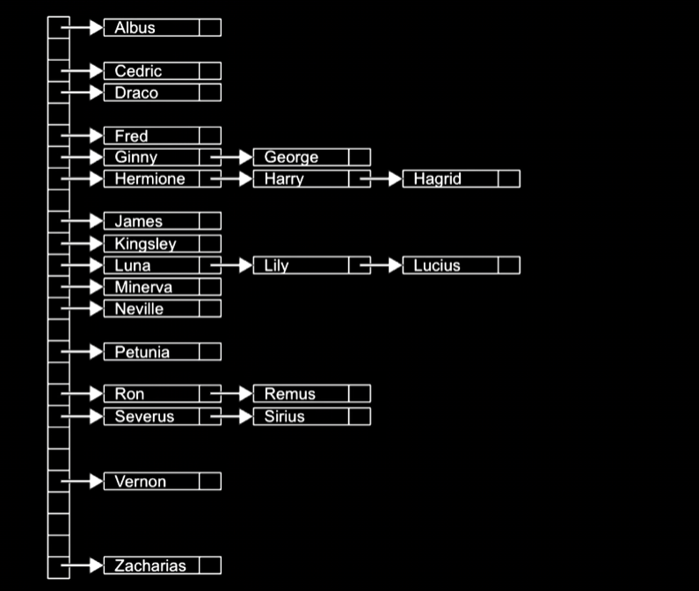

Worst case / Upper bound is still O(n) – if all names started with A it would just be one long linked list

**Tries**Executes searches in linear time

Multi-tier hash table

Height of this tree is only at max, the length of the longest name, and it only ever takes the number of letters in a single persons name in steps to search. O(1) because inserting and searching is completely independent of every other piece of data in the try

Still, tries are not used very often because it uses a lot of memory and there are so many unused elements

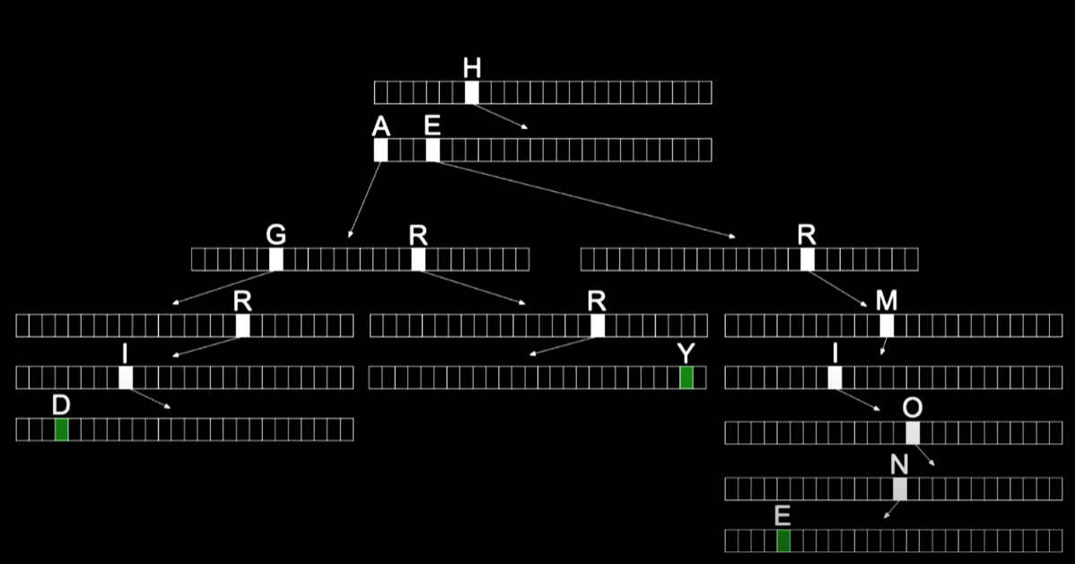

**Queues (horizontal)**

First In First Out (FIFO)

Enqueue – adding something to a queue

Dequeue – removing something from queue

**Stacks (vertical)**

Last In First Out (LIFO)

Queues vs Stacks – think stacking clothes.. with stack (dresser drawer) you may never get to bottom but queue (closet), you can take from right and always get new choices of clothes

PYTHON

Python is an interpreted language, meaning source code of python program is converted into bytecode that is executed by python virtual machine. Different from C in that it does not need a compiler.

SQL

CSV files – flat databases

CREATE

READ

UPDATE

DELETE

CREATE, INSERT

SELECT

UPDATE

DELETE, DROP

**HTML CSS JavaScript**

Router – routes data from one point to another

* Takes in data and sends it out to where it needs to go

TCP/IP – protocols that computers use to govern how they send and receive information

IP – unique numeric address for computer (32 bits / 4 bytes) #.#.#.# - max 255

TCP – specifies type of service that is in packet of information (envelope in example)

* : port
* 80 HTTP
* 443 HTTPS

Fragmentation – TCP temporarily fragment large files / packets into smaller packets to send information

* Sequence number provided so computer knows what order to re-connect packets
* Can guarantee delivery because when every packet has 1/4 number that tells you sequence, if one is missing you know you lost a packet and usually information either all gets there or none of it gets there
  + Note: you don’t always want to guarantee all or nothing transmission, for example if streaming a live event or voice call and you lose some packets because of a slow connection, you don’t want to buffer and stop, you want to catch back up to live (UDP transmission) – doesn’t keep pausing and resending

DNS – Domain Name System

* Every network on internet has a DNS server
* Configured by ISP, workplace etc
* Server connected to network you are on that has a big table that matches domain names (twitter.com) to IP addresses
* Translates fully qualified domain addresses to ip addresses

HTTP – Hypertext Transfer Protocol 80

* Web is just one section built on top of the internet

HTTPS – Hypertext Transfer Protocol Secured 443

<https://www.example.com>/

* / at end – usually not shown by browser but denotes root folder

<https://www.example.com/path>

<https://www.example.com/file.html>

* Can be an exact file

<https://www.example.com/folder/file.html>

* Folder/file.html points to a certain folder/file on web server you are programming

Example.com = domain name

[www.example.com](http://www.example.com) = fully qualified domain name

* www – refers to the HOST NAME of specific server in that domain
  + can also have mail.example.com, chat.example.com servers etc

.com - top level domain

https: - protocol

GET

* put any user input into URL

POST

* hide any user input from URL

Client request –> server response

REQUEST:

GET / HTTP/1.1

Host: [www.example.com](http://www.example.com)

RESPONSE:

HTTP/1.1 200 OK

Content-Type: text/html

301 status code automatically transfers you to a different address (<http://harvard.edu> -> <https://www.harvard.edu>)

200 OK

301 Moved Permanently

302 Found

304 Not Modified

307 Temporary Redirect

401 Unauthorized

403 Forbidden

404 Not Found

418 I’m a Teapot

500 Internal Server Error

503 Service Unavailable

HTML / CSS

* not actually programming languages

HTML

* tags and attributes
* validator.w3.org – can check your HTML code to see if any errors

<https://www.google.com/search?q=cats>

* URL is how users communicate to server, if you type “cats” into google search bar (HTML FORM), it creates the above URL to send you to search location (if form is using HTTP GET)
  + If using login/password etc form would use HTTP POST for privacy

CSS – Cascading Style Sheets

* Instead of putting html style attributes throughout html document, you can add <style> to head and put styling in there to be spread out throughout the html document
  + OR EVEN BETTER – It can be put in a completely different file!

# - used to declare id’s which can then be used to label different segments of html

Can change html in developer tools of google chrome client side but it doesn’t change in file so after refreshing it goes away. Good way to test changes

BOOTSTRAP – FRAMEWORK FOR APPLYING CSS DESIGNS

* Simply copy bootstraps codes into your html file
* Bootstrap documentation can help you style tables or other html elements easily with 1-2 changes to html code (table example from Harvard CS50 1:55:00 mark)

JavaScript

* When writing python code you are doing it on server, it is run on cloud in server
* For JavaScript, even though its written in server, it is sent to browser and executed in browser alongside HTML and CSS
  + Node.js can be used to be executed on server however

When you get a new email you don’t need to refresh page, it automatically pops up.. How?

* JavaScript code is running in background to continuously communicate with server